**J.B.S.P SANSTHA’S**

**CHANGU KANA THAKUR**

**ARTS, COMMERCE, SCIENCE COLLEGE**

**NEW PANVEL (W)**

**PROJECT REPORT**

**ON**

ONLINE PASSPORT

DEVELOPED BY

**MR. SAGAR BALASAHEB GAIKWAD**

UNDER THE GUIDANCE OF

PROF. MRS. AARTI. S. PARDESHI

**SUBMITTED TO**

**UNIVERSITY OF MUMBAI**

**2015-2016**



# Janardan Bhagat Shikshan Prasarak Sanstha’s

**CHANGU KANA THAKUR**

**Arts, Commerce, Science College**

**New Panvel (W).**

**PROJECT REPORT ON**

**Submitted to**

## University of Mumbai

2015-2016

## By

### MR.SAGAR BALASAHEB GAIKWAD

Under the Guidance Of

**PROF.MRS. AARTI S. PARDESHI**

DEPARTMENT OF COMPUTER SCIENCE

**CERTIFICATE**

This is to certify that the project entitled

**“Online Passport”**

Is successfully completed by **Mr. Sagar Balasaheb Gaikwad**, Roll No :- ITA 12.

Examination Number ______ under the guidance of **Prof. Mrs. Aarti S.Pardeshi,**

during the academic period of 15th June, 2015 to 16th January ,2016 as per the Syllabus, and the fulfillment for the completion of the B.Sc. degree in the Computer Science of University of Mumbai. It is also to certify that this is original work of the candidate done during academic year 2015-2016.

Place:

Date:

Internal Examiner Head of Department Principal

External Examiner

***Acknowledgment***

It is indeed a matter of great pleasure and proud privilege to be able to present this

Project on **“Online Passport”.**

The completion of the project work is a milestone in student life and its execution is inevitable in the hands of guide. I am highly indebted the projects guide **Prof. Mrs. Aarti S.Pardeshi** and our subject teacher **Prof. Mrs.Pratibha Jadhav**. Her invaluable guidance and appreciation for giving form and substance to this report. It is due to her enduring efforts; patience and enthusiasm, which has given a sense of direction and purposefulness to this project and ultimately made it a success.

I would like to tender our sincere thanks to the H.O.D. **Prof. Mrs. P. M. Jadhav** and all the teachers for their co-operation.

I would also like to express our deep regards and gratitude to the Principal **Dr. Mr. S. T. Gadade.**

I would wish to thank the non – teaching staff and my friends who have helped me all the time in one way or the other.

Really it is highly impossible to repay the dept of all the people who have directly or indirectly helped me for performing the project.

SAGAR BALASAHEB GAIKWAD

***INDEX***

|  |  |  |
| --- | --- | --- |
| **Sr. No.** | **Topic** | **Page No.** |
|  | Preliminary Investigation | 6 |
|  | 1. Organizational Overview | 7 |
|  | 1. Description of System | 9 |
|  | 1. Limitations of present system | 10 |
|  | 1. Proposed system | 11 |
|  | 1. Proposed systemAdvantages | 12 |
|  | 1. Feasibility Study | 13 |
|  | 1. Stakeholders | 19 |
|  | 1. Gantt Chart | 20 |
|  | System Analysis | 21 |
|  | 1. Fact Finding Techniques | 22 |
|  | 1. Event Table | 23 |
|  | 1. Use Case Diagram | 25 |
|  | 1. ERD | 26 |
|  | 1. Activity Diagram | 27 |
|  | 1. Class Diagram | 29 |
|  | 1. Object Diagram | 30 |
|  | 1. Sequence Diagram | 31 |
|  | 1. Collaboration Diagram | 32 |
|  | 1. State Diagram | 33 |
|  | System Design | 35 |
|  | 1. Converting ERD to Tables | 36 |
|  | 1. Design Class Diagram | 37 |
|  | 1. Component Diagram | 38 |
|  | 1. Package Diagram | 39 |
|  | 1. Deployment Diagram | 40 |
|  | 1. System Flow chart | 41 |
|  | 1. Structure chart | 42 |
|  | System Coding | 43 |
|  | 1. Menu Tree | 44 |
|  | 1. List of tables with attributes & constraints | 45-56 |
|  | 1. Program Description   [Programs /classes & their responsibilities in brief] with naming conventions , Validations, Screen Layout & Report Layouts | 57-138 |
|  | System Implementation | 139 |
|  | Future Enhancements | 141 |
|  | Conclusion | 143 |
|  | Bibliography | 145 |

**Chapter 1**

**Preliminary Investigation**

**Organizational Overview**

**"To deliver passport services to citizens in a timely, transparent, more**

**Accessible, reliable manner and in a comfortable environment through**

**Streamlined processes and committed, trained and motivated workforce"**

An intelligent and effective use of available resources is the key to any

Successful venture .In this complex and competitive business world, it is planning, organization and well orchestral Coordination of these resources that matter the most. Human resources are the principle element in the whole gambit. However, a very scant attention is paid to its abundant availability. This coupled with corruptive practice is major stumbling block in smooth functioning of any organization.

One of major finding of the research was the realization that a systematic

Approach to their requirement information was lacking in these organization due to variety of constraints. It was therefore felt that a professional approach to address this problem would provide some relief to the organization.

Passport Seva enables simple, efficient and transparent processes for delivery

of passport and related services. Apart from creating a country wide networked environment for Any Organization staff, it integrates with the Police for physical verification of applicant's credentials and with Passport Authority for delivery of passports.

**Organizational Chart**

Applicant

Admin

Online Passport

Passport Authority

Police Station

Regional Passport Authority

**Description of System**

Purpose of Present Online System is to promote the “Online Passport” and to manage all detail or information. If any person want to know about the Online Passport he/she get that information online so it will be user friendly and detailed information will be provided. Worldwide Applicant can involve.

Searching of the records is performed manually. All theRecords of Passport details of new Applicant and Applyfor new Passport are maintained in handwritten work. To occur them to Passport Authority must have to know each and all records in the project which is difficult or else they cannot manage it. As the job is done manually, it has its own limitation.

For preparing record on daily and monthly basic Passport Authority have to face many difficulties and was not possible to maintain records manually.

In Present Online System, the work of block search is done manually. Any manually result lead to wrong interpretation of result.

Offices in multiple locations can handle their records, transaction easily and avoid lot of travel. IT helps from the manual work from which is very difficult to finds the records of the Applicant Passport detail and all detail about the system.

So definitely the proposed system will overcome all the problems and also system becomes quite easier then present system.

.

**Limitation of Present System**

* All the work done is manually. This is very error prone due to extra human interface.
* Data stored are inconsistent & there is centralization of data.
* Also the data is not abstracted from everyone & loads to data loss at any disaster.
* There is also replication & redundancy in the data storage.
* To enter manual data, was much more tedious.
* Lack of security or Data security is not assured.
* No backup power.
* Manual mistake appear.
* More paper wastage.
* It is difficult to maintain records in long run.
* It is difficult to keep records in registers for many years of some month’ssafety.
* Difficulty in managing multiple forms.

**Proposed System**

* The proposed system is computerized and has been developed using advance language therefore it gives more facilities than present system.
* It provides quick access to any data. In this system user have to enter the data only once and then it get linked with all files.
* This reduces the workload of Applicant and it is also a time saving process.
* The information about any Applicant can be easily retrieved. The system maintains all records easy.
* You can check the personal details of all current Applicant within few minutes the database of the system will help you to check a particular one.
* It helps to increase the number of Applicant.
* As its online people around the world can take its advantages, and can communicate with system.
* This Website is developed for Online Passport. To handles all the Applicant, Services Database, records finish good and all report generation.
* The Project is based on various events that are managed by Online System and its Services.
* Using this project will allow a standard approach and a more convenient &Faster. Information about the Applicant Details & also Passport Detail etc. be easily retrieved. This system maintains all records easy.

**Advantage of Proposed System**

The proposed system for “Online Passport” is computerized.

Today is the era of computers.

* All the information about Applicant details, Passport details will be maintain properly in this system.
* All manual calculations of Passport or all the money management will be performed by the computer automatically.
* This system will provide timely report information.
* It will produce report for Applicant and Passport information.
* The computer can hold amount of data in its storage device.
* We can generate result or print any report within a second.
* The operations and speed of the computer is very high.
* We can calculate result and print any report in less time.
* Any difficulties we can solve easily.
* A Database Applications can be stored in computer effectively.
* It is very user friendly and easy to handle.
* So the computerized system is more suitable than manual system.

**Feasibility Study**

Feasibility study tells whether the system would be beneficial for the organization with respect of the organization. Feasibility study is divided into following phases

**Phase of feasibility:**

1. **Operational Feasibility:**

Operational feasibility is dependent on the human resources available for the project and involves projecting whether the system will operate and be used once it is installed. The proposed system is according to the requirements of the Auto Fuel Technologies, and after when it will be implemented in the AFT, is likely to yield benefits for the whole Company. As the people are already familiar with using application programs like Microsoft Office so, there is no chance of any sort of destructive resistance to the implementation of this project. It is mainly concerned with the availability of human resources for the project and it also tells whether the system would be operating -able after its deployment or not. If the project meets the needs of an organization then it is operationally feasible. The proposed system would be beneficial in this regard as it would be exactly according to user requirements and will give the guarantee of complete data security. It will provide the end users with timely pertinent, accurate and usefully formatted information by making a full use of the available resources.

1. **Technological Feasibility:**

Technical feasibility is a measurement of the practicality of a specific technical solution and the availability of technical resources and expertise. Today, very little is technically impossible, consequently, technical feasibility looks at what is practical and reasonable. It is the measure of specific technical solution and the availability of technical resource and expertise. In technical feasibility we see that the technology in which we are implementing the project provides data security, reliability and ease of access. In Auto Fuel Technologies project I use vb.Net a powerful, productive and extensible programming environment.ASP.Net unlocks the door toward the development of project. For Database I use SQL server 2000, which has power to hold the data for heavy project. Technical feasibility addresses three major issues: Is the proposed technology or solution practical? Do we currently possess the necessary technology? Do we possess the necessary technical expertise and is the schedule reasonable? Yes! Technical problem can be there if there is no computer operator .So there should be a computer operator for current working of the software and different technical issues will be solved during the testing process. A large part of determining resources has to do with accessing technical feasibility. If existing system cannot be added onto then the next question becomes whether there is technology in existence that meets the specification.

1. **Social Feasibility:**

With the deployment of the new system on one hand the organization got benefited but on the other hand it also affects the employees of the organization .Social Feasibility is done in order to check this effect. It checks whether the system affects the job of employees and how much it affects the employees. The social evaluation how the proposed system may improve the job and the working environment of those affected. My proposed system will affect the staff of the organization. As many persons would be enough to run this system despite how many manual records keepers, but other persons would be accommodated on the other places as the organization is escalating and he see that person are worked in proper way or not. In AFT I have to see that the staff working in Auto Fuel Technical has knowledge of how to use the technology as well as user training to use the project.

1. **Economical and Financial Feasibility:**

Economic Feasibility is the measurement of the cost effectiveness of the project proposed system. The bottom line in many projects is economic feasibility. During the early phase of the perfect economic feasibility analysis amount little more judging whether the possible benefits of the solution or worthwhile. Costs are practically impossible to estimate at that stage because the end user requirement and alternative technical solutions have not been identified. However as soon as specific requirement have been identified, the analyst can weigh the cost and benefit of each alternative solution. This called the cost and benefit analysis. It is the measure of cost effectiveness of a project. This is often calling cost and benefits analysis. So in economical feasibility we see what cost required implementing the new system. In AFT Automation system I have to see what costs are involved. So I have to consider all the facts that are related to new system cost.

**Software Specification:**

**Software requirements for this system are as listed follows:**

|  |  |
| --- | --- |
| **Front End** | ASP.NET |
| **Back End** | MICROSOFT SQL SERVER 2008 |
| **Operating system** | Windows 7 |

**Hardware Specification:**

**Hardware requirements for this system are as listed follows:**

|  |  |
| --- | --- |
| **Processor** | Dual Core |
| **RAM** | 4GB |
| **Free Hard Disk Space** | 500 GB |

## FRONT END: ASP.NET

**What is ASP.NET?**

ASP.NET is a server side scripting technology that enables scripts(embedded in which web pages)to be executed by an Internet Server.

* ASP.NET is a Microsoft Technology
* ASP stands for Active server pages.
* ASP.NET is a Program that runs inside IIS.
* IIS(Internet Information services)is Microsoft Internet Server.
* IIS comes as free Component with Windows server.
* IIS is also a part of Windows 2000 and XP Professional.

**What is ASP.NET file?**

* An ASP.NET file is just the same as an HTML file.
* An ASP.NET file can contain HTML,XML, and scripts.
* Scripts in an ASP.NET file are executed on the server.
* AN ASP.NET file has the file extension ”.aspx”.

**How does ASP.NET work?**

* When a browser request an HTML file ,the server return the file.
* When a browser requests an ASP.NET engine reads the file, line and executes the scripts in the file.
* Finally, the ASP.NET file is returned to the browser as plain HTML.

**THE MICROSOFT.NET FRAMEWORK**

The .Net Framework is the infrastructure for the Microsoft.NET platform.The .Net Framework is an environment for building, deploying and running web application and web services.Microsoft first server technology ASP(Active Server Pages),was a powerful and flexible “programming language”. But it was too code oriented. It was not an application framework and not an enterprise development tool.

**.NET Framework Keywords:**

* Easier and quicker programming.
* Reduced amount of code.
* Declarative programming model.
* Richer server control hierarchy with events.
* Larger class library.
* Better support for development tools.

The .Net Framework consist of 3 main parts.

**Programming language:**

* C Sharp(C#.NET)

**Server technology and client technologies:**

* ASP.NET(Active Server Pages)
* Window forms(Windows desktop solutions)
* Compact Framework(PDA/Mobile solutions)

**Development Environments:**

* Visual Studio.NET(VS.NET)
* Visual Web Develop

**ASP.NET 2.0:**

* ASP .NET 2.0 improves upon ASP.NET adding support for several new features

**ASP.NET 3.0:**

* ASP.NET 3.0 is not a new version of ASP.NET. It’s just name for a new ASP.NET 2.0 framework library with support for Windows Presentation Foundation. Windows Communication Foundation, Window Workflow Foundation and Window Card Space.

**BACKENDD: SQL SERVER 2008**

IBM developed the original version of SQL, originally called Sequel, as part of the System R Project in the early 1970s. The Sequel language has evolved since then, and its name has changed to SQL [Structure Query language]. Many products now support the SQL language. SQL has clearly established itself as the standard Relational Database Language.

In 1986, the American Standards Institute [ANSI] and the International Organization for Standardization [ISO] published an SQL standard, called SQL-86. ANSI published an extended standard for SQL, SQl-89, in 1989. The next version of the standard was SQl-92 standard followed by SQL: 1999; the most recent version are SQL: 2003, SQL: 2005 and then SQL: 2008.

The SQL language has several parts:

* Data Definition Language [DDL]: The SQL DDL provides commands for defining relation schemas, deleting relations, and modifying relation schemas.
* Interactive Data-Manipulation Language [DML]: The SQL DML includes a query language based on both the relational algebra [2] and tuple relational calculus [5]. It includes also commands for specifying integrity constraints that the data stored in the database must satisfy. Updates that violate integrity constraints are disallowed.
* View Definition: The SQL DDL includes command for defining views.
* Transaction Control: SQL includes commands for specifying the beginning and ending of transactions.
* Embedded SQL and Dynamic SQL: Embedded and Dynamic SQL define how SQL statements can be embedded within general-purpose programming language, such as C, C++, JAVA, PL/SQL, COBOL, Pascal, and FORTRAN.
* Authorization: The SQL DDL includes commands for specifying access rights relations and views.

**Stakeholders**

Stakeholders are anyone who has an interest in the project. Project stakeholders are individuals and organizations that are actively involved in the project, or whose interests may be affected as a result of project execution or project completion. They may also exert influence over the project’s objectives and outcomes. The project management team must identify the stakeholders, determine their requirements and expectations, and, to the extent possible, manage their influence in relation to the requirements to ensure a successful project.

The following are examples of project stakeholders:

1. **Project Developers**

Project Developers is one who develops software for customer. In my project I

Am the first stakeholder i.e. Project Developer.

1. **Project customer**

Project Customer is one who pays for the developed software.

1. **Project user Group**

Project User group are those people who use the software on daily basis for

The Project Customer.

1. **Project Testers:**

Project Testers are those who test the software. In my project myself, my

Project guide are the Project Testers.

**Gantt Chart**

|  |  |  |
| --- | --- | --- |
| **Phase** | **Start date** | **Completion date** |
| **Preliminary investigation** | **15/06/**  **2015** | **30/06/ 2015** |
| **Project Finalization** | **15/06/**  **2015** | **22/06/ 2015** |
| **Investigation of system requirement** | **23/06/2015** | **30/06/ 2015** |
| **System Analysis** | **01/07/2015** | **17/07/ 2015** |
| **System Design** | **20/07/2015** | **25/07/ 2015** |
| **Coding** | **27/07/2015** | **11/09/ 2015** |
| **Interface Coding** | **27/07/2015** | **27/08/ 2015** |
| **Database Connectivity** | **28/08/2015** | **05/09/ 2015** |
| **Validation Coding** | **06/09/2015** | **08/09/ 2015** |
| **Report Coding** | **08/09/2015** | **11/09/ 2015** |
| **Implementation** | **11/09/ 2015** | **23/11/ 2015** |
| **Developer Testing** | **24/11/2015** | **30/11/ 2015** |
| **Client Testing** | **01/12/2015** | **10/12/ 2015** |
| **User Testing** | **11/12/2015** | **19/12/ 2015** |
| **Project Delivery** | **21/12/2015** | **80/12/ 2015** |
| **Project Report Submission** | **01/01/ 2016** | **09/01/ 2016** |
| **Project Report Hard Copy Checking** | **10/01/ 2016** | **13/01/ 2016** |
| **Project Submission** | **13/01/ 2016** | **16/01/ 2016**  **1 2 3 4 5 6 7 8 9 10 11 12 13 14 15 16 17 18 19 20 21 22 23 24 25 26 27 28 29 30**  **WEEK** |

***Chapter 2***

**System Analysis**

**Fact Finding**

**Introduction**

The Current System is the manual one, hence is not speedy, accurate, efficient as well as time consuming. An essential part of the system analysis, which enables the developer to understand & the system correctly. It is undertaken to obtain details of the system. To understand the physical flow of the information through the current system. Collect various information through various fact finding techniques. Identify the procedural difficulties experienced by the user. Study the bottlenecks find out the redundant work being performed in the system.

**Fact Finding Techniques Employed**

1. **Interviews**

Information was obtained from the employees at the organization by interviewing them at the location and time convention both.

1. **Document Searching**

An extensive study of existing document an official correspondence was done to understand the present working status of organization.

**Event Table**

|  |  |  |  |  |  |  |
| --- | --- | --- | --- | --- | --- | --- |
| **SR.NO** | **EVENT** | **TRIGGER** | **SOURCE** | **ACTIVITY** | **RESPONSE** | **DESTINATION** |
| **1.** | Applicant Registration | Fill the Details | Applicant | Submit The Registration Form | Applicant is Registered | Admin |
| **2.** | Applicant Login | Check Detail Registration | Applicant | User is Logged In | Applicant is Authorized | Admin |
| **3.** | Visit the Website | Check the Website | Applicant | Check the Details | Get the Information | Admin |
| **4.** | Elect the Specific Type Info | Check its Details | Applicant | Read the Details | Get Information | Admin |
| **5.** | Fill the Passport Form | Check the Form Details | Applicant | Applicant Submit Form | Passport  Form Submited | Admin |
| **6.** | Fill the PCC Form | Check the Form Details | Applicant | Applicant Submit Form | PCC Form Submited | Admin |
| **7.** | Fill the IDC Form | Check the Form Details | Applicant | Applicant Submit Form | IDC Form Submited | Admin |
| **8.** | Fill the SA Form | Check the Form Details | Applicant | Applicant Submit Form | SA Form Submited | Admin |
| **9.** | Fill the LoC Form | Check the Form Details | Applicant | Applicant Submit Form | LoC Form Submited | Admin |
| **10.** | Fill the SC Form | Check Criminal Details | Applicant | Applicant Submit Form | SC Form Submited | Admin |
| **11.** | Fill Payement  Form | Check the Payments  Details | Applicant | Pay  Payment | Payment  is Done | Admin |
| **12.** | Appointment | Check Appointment  Status | Applicant | Confirm Appointment | Appointment  Confirmed | Admin |
| **13.** | Logout | Transaction done | Applicant | Applicant Logging Out | Applicant  Logged Out | Admin |
| **14.** | Document  Submission | Submission | Applicant | Verify  Document | Document  Submitted | Passport  Authority |
| **15.** | Document Verification | Verification | Passport  Authority | Verification | Verification Done | Regional  Passport  Authority |
| **16.** | Document Verification | Verification | Regional  Passport  Authority | Verification | Verification Done | Police  Station |
| **17.** | Passport  Issue | Check Status of Passport  issue | Passport  Authority | Passport is getting  Issued | Passport  Issued | Applicant |

**Use Case Diagram**

Applicant

Passport Authority

Police Station

**Entity-Relationship Diagram**

Payment

FeedBack

Query

Applicant

SC

LoC

PCC

Passport

Admin

**Activity Diagram**

Visit Website

Submit Registration Form

Applicant Login

No

Yes

Applicant Authorized

Apply New Passport

No

Yes

Submit Passport Form

Submit PCC Form

No

Apply For LoC

Yes

Submit LoC Form

Yes

Apply For SC

No

Submit SC Form

No

Yes

Apply For IDC

Submit IDC Form

Check Appointment Status

Logout

Submit Documents

Passport Issued

**Class Diagram**

Admin

Applicant

adminID

LoginID

Password

userID

ApplicantName

Address

DateofBirth

Gender

ContactNo

EmailID

FileNo

PassportNo

Insert ()

Update ()

GetAdminInfo ()

Insert ()

Continue ()

**Object Diagram**

Insert ()

Update ()

GetAdminInfo ()

Admin

1

ADMIN

epassport

Applicant

12

Sagar Worriors

Sukapur

D15/02/1995

Male

9820639778

Epassport18@gmail.com

125368R9

99T15295

Insert ()

Continue ()

**Sequence Diagram**

Passport Authority

Police Station

Admin

Applicant

Visit the Website

Check if New Applicant

Registered New Account

Login Website

Applicant Is Authorized

Apply for New Passport

Apply for PCC

Apply for LoC

Apply for SC

Apply for IDC

Forms Verified

Payment Inquiry

Confirm Appointment Status

Logout

Document Submitted

Document Verified

Verify Applicant Details

Police Verification Details

Get Passport

**Collaboration Diagram**

Admin 14.Generate Report

1. Visit Website

2. Get Information

3. Check if new Applicant

4. Account Registered

5. Login Website

6. Applicant Authorized

7. Submit Passport Application Form

8. Submit PCC Form

9. Submit LoC Form

10. Submit SC Form

11. Submit IDC Form

12. Submit Payments Details

12. Retrieve Appointment

Status

13. Logout

Applicant

15. Document Submission

16. Verify Document

Passport Authority

17. Verify Applicant Details

18. Verify PCCDetails

19. Get Passport

Police Station

**State Diagram**

Idle

New Applicant

Applicant Registered

ApplicantNot

Authorized Applicant Authorized

Login

Inquiry for Passport

Passport Application Form

PCC Form

LoC for Jammu & Kashmir Resident

SC for Who getting Foreign Nationality

IDC For Stateless Resident People

Payment

Confirm Appointment Status

Logout

Document Submitted

Document Verified

Police Verification Done

Get Passport

**Chapter 3**

**System Design**

**Converting ERD to Tables**

|  |  |  |
| --- | --- | --- |
| **Sr.No** | **TABLE NAME** | **PURPOSE** |
| 1 | NewUserRegistration.sql | This table is use to store, retrieve and information about the Applicant  The field are userID, Passport_Office,  First_Name, Middle_Name, Last_Name,  Email_ID,Login_ID,Password, Mobile_No,  Passport_no, File_No.etc |
| 2 | PassportApplicationForm.sql | This table is use to store, retrieve and information about the Passport Application Details.  The field are userID, ApplicantName, Address, ContactNo, Email, Gender,  DateofBirth,Country,PanNo,AdharNo,  Educational_Qualification,FaherName,Country, Permenant_Address, Warant_Details etc, |
| 3 | PoliceClearenceCertificate  Form.sql | This table is use to retrieve& Store and also information about the Police Verification for Applicant.  The field are userID, File_Number,Date_of_Issue,Date_of_Expiry, ApplicantDetails, Current Address, Permanent Address etc. |
| 4 | LineofControlForm.sql | This table is use retrieve & Store and also information about the Applicant Which is residing in Jamu & Kashmir.  The field are userID,Permit_Type,Gender,Date_of_Birth, ApplicantDetails,Address, ContactNo,Email_ID, PurposeofVisit,  References Details, etc |
| 5 | SurrenderCertificate  Form.sql | This table is use retrieve & Store and also information about the Applicant Whose have Foreign Nationality.  The field are userID, Passport_No , Date_of_Issue, Date_of_Expiry,Address,  Education Qualification etc |
| 6 | IdentityCertificateForm.sql | This table is use retrieve & Store and also information about the Applicant for Those people are Stateless & Tibetan Refuges.  The field areuserID, Applicant Detail, Address, Family Details, Contact Details, Year of Applying etc. |
| 7 | Payments.sql | This table is use retrieve & Store and also information about the Applicant Payments Details.  The field are userID, Debit No, Card No, CVC Number, Bank No etc. |
| 8 | CashPayments.sql | This table is use retrieve & Store and also information about the Applicant Cash/DD Payments Details.  The field are userID, DD No, Bank Name, IFSC Code etc. |
| 9 | FeedBack.sql | This table is use to Save and show the FeedBack of Applicant or Visitor.  The field are Name, Mobile_No, File_No, Email ID, FeedBack |
| 10 | AskQuery.sql | This table is use retrieve & Store and also information about the Applicant Query Details.  The field are ID, Email_ID, Subject,  Query ,etc |

**Component Diagram**

NewUserRegistration

.aspx

PassportApplicationForm

.aspx

PoliceClearenceCertificate

Form.aspx

Online

Passport

LineofControlForm

.aspx

SerrenderCertificateForm

.aspx

IdentityCertificateForm

.aspx

Payment.aspx

AppointmentStatusForm

.aspx

FeedBack.aspx

AdminHome.aspx

**Package Diagram**

**Home**

NewUserRegistration.aspx

HomePage.aspx

Online

Passport

AdminHomePage.aspx

**Entry**

IdentityCertificate

Form.aspx

PassportApplicati

onForm.aspx

Payment.aspx

PoliceClearanceCertificateForm.aspx

Appointment

Status.aspx

LineofControl

Form.aspx

FeedBack.aspx

SurrenderCertificateApplicationForm.aspx

AskQuery.aspx

**Deployment Diagram**

Payment.aspx

NewUserRegistra

tion.aspx

Appointment

Status.aspx

PassportApplicati

onForm.aspx

FeedBack.aspx

PoliceClearanceCertificateForm.aspx

Online

Passport

AskQuery.aspx

LineofControl

Form.aspx

SurrenderCertificateApplicationForm.aspx

AdminHome.aspx

Terminal

HUB

Printer

IdentityCertificate

Form.aspx

**LOCAL AREA NETWORK**

**System Flow Charts**

NewUserRegistra

tion

Maintain New Applicant Details

New Applicant report

Passport office report

Maintain Applicant Passport Details

Passport Details

tion

Maintain Applicant PCC details

Online Passport

PCC Details

Maintain Surrender

Details

SC Details

Maintain

Identity

Details

IDC Details

Maintain Appointmentdetails

Document Details

Applicant Query report

Maintain

Payments

Details

Query Details

FeedBack

Details

Applicant FeedBack report

Maintain

Document

Details

Maintain

Passport Issued

Details

Passport Issued Details

**Structure Chart**

**Online Passport**

Applicant

Details

Admin

Applicant

Query

Details

Applicant Details

Passport Details

FeedBack

Details

PCC

Details

Appointment Details

LoC Details

Payments

Details

IDC Details

SC

Details

**Chapter 4**

**System Coding**

**Menu Tree**

Home

Passport Details

Applicant

FAQ

Home

FeedBack

Ask Query

Change Password

About Us

Appointment Status

**Online Passport**

Contact Us

Logout

FeedBack

Login

Home

Applicant Details

FeedBack

Admin

Query Details

Send Mail

Logout

**List of tables with attributes &constraints**

**Tables Used**

|  |  |  |
| --- | --- | --- |
| **Sr.No** | **TABLE NAME** | **Fields** |
| 1 | NewUserRegistration.sql | userID, Passport_Office, First_Name,  Middle_Name, Last_Name, Email_ID,  Login_ID, Password, Mobile_No,  Passport_no, File_No.etc |
| 2 | PassportApplicationForm.sql | userID, ApplicantName, Address, ContactNo, Email, Gender,  DateofBirth,Country,PanNo,AdharNo,  Educational_Qualification,FaherName,Country, Permenant_Address, Warant_Details etc, |
| 3 | PolceClearenceCertificate  Form.sql | userID, File_Number,Date_of_Issue,Date_of_Expiry, Applicant Details, Family Details, Current Address, Permanent Address, Reference Details etc. |
| 4 | LineofControlForm.sql | userID,Permit_Type,Gender,Date_of_Birth, ApplicantDetails,Address, ContactNo,Email_ID, PurposeofVisit,  References Details, etc |
| 5 | SurrenderCertificate  Form.sql | userID, Passport_No , Date_of_Issue, Date_of_Expiry,Address,  Education Qualification etc |
| 6 | IdentityCertificateForm.sql | userID, Applicant Detail, Address, Family Details, Contact Details, Year of Applying etc. |
| 7 | Payments.sql | userID, Debit No, Card No, CVC Number, Bank No etc. |
| 8 | CashPayments.sql | userID, DD No, Bank Name,  IFSC Code etc |
| 9 | FeedBack.sql | Name, Mobile_No, File_No, EmailID, FeedBack etc. |
| 10 | AskQuery.sql | ID, Email_ID, Subject, Query ,etc. |

**Maintenance Table**

**1. Tablename : -** NewUserRegistration

Description: it provides information of New Applicant Registered Details

|  |  |  |  |  |  |
| --- | --- | --- | --- | --- | --- |
| **Sr.No.** | **Field Name** | **Data type** | **Constraints** | **Size** | **Description** |
| 1 | userID | Integer | Primary key |  | Stores the Applicant Registered id |
| 2 | PassportOffice | nvarchar |  | 50 | Stores the Applicant  Apply passport office |
| 3 | FirstName | nvarchar |  | 50 | Stores the Applicant  First Name |
| 4 | MiddleName | nvarchar |  | 50 | Stores the Applicant  Middle Name |
| 5 | LastName | nvarchar |  | 50 | Stores the Applicant  Last Name |
| 6 | DateofBirth | nvarchar |  | 50 | Stores the Applicant  Date of Birth |
| 7 | Login_ID | nvarchar |  | 50 | Stores the Applicant  Login ID |
| 8 | Password | nvarchar |  | 50 | Stores the Applicant  Password |
| 9 | File_No | nvarchar |  | 50 | Stores the Applicant  File Number |
| 10 | Passport_No | nvarchar |  | 50 | Stores the Applicant  Passport No |

**2. Table name:-**PassportApplicationForm

Description: it provides information of Passport Application Details of Applicant

|  |  |  |  |  |  |
| --- | --- | --- | --- | --- | --- |
| **Sr.No.** | **Field Name** | **Data type** | **Constraints** | **Size** | **Description** |
| 1 | userID | Integer | Primary key |  | Stores the Applicant Registered id |
| 2 | Applying for | nvarchar |  | 50 | Stores the Passport Details such as Fresh |
| 3 | Applicant's Name | nvarchar |  | 50 | Stores the Applicant  Name |
| 4 | Gender | nvarchar |  | 50 | Stores the Applicant  Gender |
| 5 | Date of Birth | nvarchar |  | 50 | Stores the Applicant of Date of Birth |
| 6 | Marital Status | nvarchar |  | 50 | Stores the Applicant Marital Status |
| 7 | Employment Type | nvarchar |  | 50 | Stores the Applicant Employment Type |
| 8 | Aadhaar Number | nvarchar |  | 50 | Stores the Applicant  Aadhaar Number |
| 9 | Father's Name | nvarchar |  | 50 | Stores the Applicant  Father's Name |
| 10 | Mother's Name | nvarchar |  | 50 | Stores the Applicant  Mother's Name |
| 11 | Residential Details | nvarchar |  | 50 | Stores the Applicant  Residential Details |
| 12 | Mobile No | nvarchar |  | 50 | Stores the Applicant  Mobile No |
| 13 | E-mail ID | nvarchar |  | 50 | Stores the Applicant  E-mail ID |
| 14 | Arrest warrant | nvarchar |  | 50 | Stores the Applicant  Arrest warrant |

**3. Table name:-**PoliceClearanceCertificateForm

Description: it contains information Applicant Police Clearance Certificate

|  |  |  |  |  |  |
| --- | --- | --- | --- | --- | --- |
| **Sr.No.** | **Field Name** | **Data type** | **Constraints** | **Size** | **Description** |
| 1 | userID | Integer | Primary key |  | Stores the Applicant Registered id |
| 2 | File Number | nvarchar |  | 50 | Stores the File Number |
| 3 | Date ofIssue | nvarchar |  | 50 | Stores the Date ofIssue |
| 4 | Date of Expiry | nvarchar |  | 50 | Stores the Date of Expiry |
| 5 | Applicant's  Name | nvarchar |  | 50 | Stores the Applicant  Name |
| 6 | Father's  Name | nvarchar |  | 50 | Stores the ApplicantFather's Name |
| 7 | Mother  Name | nvarchar |  | 50 | Stores the Applicant Mother Name |
| 8 | Guardian'sName | nvarchar |  | 50 | Stores the Applicant Guardian'sName |
| 9 | Resident  Address | nvarchar |  | 50 | Stores the ApplicantResident Address |
| 10 | Mobile Number | nvarchar |  | 50 | Stores the ApplicantMobile Number |
| 11 | Reference  Name | nvarchar |  | 100 | Stores the ApplicantReferenceName |
| 12 | Reference  Mob No | nvarchar |  | 50 | Stores the ApplicantReferenceMob No |

**4. Table name:-**LineofControlForm

Description: it contains information about the Line of Control Permit

|  |  |  |  |  |  |
| --- | --- | --- | --- | --- | --- |
| **Sr.No.** | **Field Name** | **Data type** | **Constraints** | **Size** | **Description** |
| 1 | userID | Integer | Primary key |  | Stores the Applicant id |
| 2 | Permit Type | nvarchar |  | 50 | Stores the Permit Type |
| 3 | Date of Birth | nvarchar |  | 50 | Stores the Date of Birth of Applicant |
| 4 | Applicant's  Name | nvarchar |  | 50 | Stores the Applicant's Name |
| 5 | Marital Status | nvarchar |  | 50 | Stores the Marital Status |
| 6 | Religion | nvarchar |  | 50 | Store the Religion |
| 7 | Father's  Name | nvarchar |  | 50 | Store theFather'sName |
| 8 | Mother's  Name | nvarchar |  | 50 | Stores the Mother's  Name |
| 9 | Residing Since | nvarchar |  | 50 | Stores the Residing Since |
| 10 | Mobile Number | nvarchar |  | 50 | Stores the  Mobile Number |
| 11 | Email ID | nvarchar |  | 50 | Stores the Email ID |
| 12 | Places to be Visited | nvarchar |  | 100 | Stores the Places to be Visited |
| 13 | Emergency Name | nvarchar |  | 100 | Stores Emergency Name |
| 14 | Reference Name | nvarchar |  | 100 | Stores the Reference Name |
| 15 | Reference  Relative India | nvarchar |  | 100 | Stores the Reference  Relative Name |

**5.Table name:-**SurrenderCertificateApplicationForm

Description: it contains information about the distributorSurrender of Passport

|  |  |  |  |  |  |
| --- | --- | --- | --- | --- | --- |
| **Sr.No.** | **Field Name** | **Data type** | **Constraints** | **Size** | **Description** |
| 1 | userID | Integer | Primary key |  | Stores the Applicant id |
| 2 | Passport Number | nvarchar |  | 50 | Stores the Passport No |
| 3 | Date of Issue | nvarchar |  | 50 | Stores the Date of Issue |
| 4 | Date of Expiry | nvarchar |  | 50 | Stores the Date of Expiry |
| 5 | Reason for Surrender | nvarchar |  | 50 | Stores the Reason for Surrender |
| 6 | Applicant's  Name | nvarchar |  | 50 | Store the Applicant's  Name |
| 7 | Date of Birth | nvarchar |  | 50 | Stores theDate of Birth of Applicant |
| 8 | Gender | nvarchar |  | 50 | Stores theGender of Applicant |
| 9 | Father's Name | nvarchar |  | 50 | Stores theFather's Name |
| 10 | Mother's Name | nvarchar |  | 50 | Stores theMother's Name |
| 11 | Legal Guardian'sName | nvarchar |  | 50 | Stores theLegal Guardian'sName |
| 12 | Guardian's Address | nvarchar |  | 100 | Stores theGuardian's Address |
| 13 | Emergency Name | nvarchar |  | 50 | Stores the Emergency Name |
| 14 | Emergency Mobile Number | nvarchar |  | 50 | Stores the Emergency Mobile Number |
| 15 | Emergency Telephone No | nvarchar |  | 50 | Stores the Emergency Telephone No |

**6. Tablename : -**IdentityCertificateForm

Description: it contains information about the Applicant whose are belong to Stateless or Tibejen Refuges.

|  |  |  |  |  |  |
| --- | --- | --- | --- | --- | --- |
| **Sr.No.** | **Field Name** | **Data type** | **Constraints** | **Size** | **Description** |
| 1 | userID | Integer | Primary key |  | Stores the Applicant ID |
| 2 | Applying for | Integer |  |  | Stores the why Applying |
| 3 | Applicant's  Name | nvarchar |  | 50 | Stores the Applicant Name |
| 4 | Gender | nvarchar |  | 50 | Stores the Gender of Applicant |
| 5 | Date of Birth | nvarchar |  | 50 | Stores the Date of BirthApplicant |
| 6 | Height | nvarchar |  | 50 | Stores the Height Applicant |
| 7 | Color of Eyes | nvarchar |  | 50 | Stores the Marital Status Applicant |
| 8 | Marital Status | nvarchar |  | 50 | Stores the Marital StatusApplicant |
| 9 | Father's Name | nvarchar |  | 50 | Stores the Father's NameApplicant |
| 10 | Mother's Name | nvarchar |  | 50 | Stores the Mother NameApplicant |
| 11 | House No. | nvarchar |  | 50 | Stores the House No.Applicant |
| 12 | District | nvarchar |  | 50 | Stores the District Applicant |
| 13 | Police Station | nvarchar |  | 50 | Stores the Police Station |
| 14 | Mobile Number | nvarchar |  | 50 | Stores the Mobile Number |
| 15 | E-mail ID | nvarchar |  | 50 | Stores the E-mail ID |
| 16 | Emergency  Name | nvarchar |  | 100 | Stores Emergency  Nameof Applicant |
| 17 | Emergency  Mobile | nvarchar |  | 100 | Stores Emergency  Mobile No |

**7. Table name:-**Payments

Description: it contains information about the Payments of Applicant.

|  |  |  |  |  |  |
| --- | --- | --- | --- | --- | --- |
| **Sr.No.** | **Field Name** | **Data type** | **Constraints** | **Size** | **Description** |
| 1 | userID | Integer | Primary key |  | Stores the Applicant id |
| 2 | Type of Payments | nvarchar |  | 50 | Stores the Type of Payments |
| 3 | Bank Name | nvarchar |  | 50 | Stores the Bank Name |
| 4 | Card Type | nvarchar |  | 50 | Stores the Card Type |
| 5 | CVC Number | nvarchar |  | 50 | Stores the CVC Number |
| 6 | Expiry Month/Year | nvarchar |  | 50 | Stores the Expiry Month/Year |

**8. Table name:-**CashPayment

Description: it contains information about the Cash/DD Payments of Applicant

|  |  |  |  |  |  |
| --- | --- | --- | --- | --- | --- |
| **Sr.No.** | **Field Name** | **Data type** | **Constraints** | **Size** | **Description** |
| 1 | userID | integer | Primary key |  | Stores the Applicant ID |
| 2 | Type of Payments | nvarchar |  | 50 | Stores the Type of Payments |
| 3 | Bank Name | nvarchar |  | 50 | Stores the Bank Name |
| 4 | DD Number | integer |  |  | Stores the DD Number |
| 5 | Bank IFSC Code | integer |  |  | Stores the Bank IFSC Code |

**9. Table name:-**AskQuery

Description: it contains information about the Query .

|  |  |  |  |  |  |
| --- | --- | --- | --- | --- | --- |
| **Sr.No.** | **Field Name** | **Data type** | **Constraints** | **Size** | **Description** |
| 1 | Name | nvarchar |  | 50 | Stores the Name |
| 2 | Email | nvarchar |  | 50 | Stores the Email |
| 3 | Subject | nvarchar |  | 50 | Stores the Subject |
| 4 | Query | nvarchar |  | 100 | Stores the Query |

**10. Table name:-**FeedBack

Description: it contains information about the FeedBack .

|  |  |  |  |  |  |
| --- | --- | --- | --- | --- | --- |
| **Sr.No.** | **Field Name** | **Data type** | **Constraints** | **Size** | **Description** |
| 1 | Name | nvarchar |  | 50 | Stores the Name |
| 2 | Mobile No | nvarchar |  | 50 | Stores the Mobile No |
| 3 | Email | nvarchar |  | 50 | Stores the Email |
| 4 | File No | nvarchar |  | 50 | Stores the  File No |
| 5 | FeedBack | nvarchar |  | 100 | Stores the  FeedBack |

**Program List**

|  |  |  |
| --- | --- | --- |
| **NO** | **FORM NAME** | **PURPOSE** |
| 1 | HomePage | This form display the home page of website |
| 2 | OFS | This form display the How to Apply the Passport Application |
| 3 | NewUserRegistration | This form is used for NewUserRegistrationfor Applicant |
| 4 | MemberLogin | This form is used for security with the help of password |
| 5 | FormStatus | This form is use for to display the form Details |
| 6 | UploadPhoto | This form is use for store or upload the Photo and Signature |
| 7 | PassportApplicationForm | This form is use for store the Passport information |
| 8 | PoliceClearanceCertificateForm | This form is use for store the PoliceClearanceCertificate information |
| 9 | HowApplyLOCPermit | This form is use for HowApply Line of Control Permit |
| 10 | LineofControlForm | This form is use for store the information whose live in Jammu & Kashmir |
| 11 | SurrenderCertificateApplicationForm | This form is use for store the SurrenderCertificate information |
| 12 | IdentityCertificateForm | This form is use for store the IdentityCertificateinformation |
| 13 | DocumentAttachment | This form is use for Upload the Scan copy of Document |
| 14 | Payments | This form is use for store the  Paymentsinformation |
| 15 | CashPayment | This form is use for store the  CashPaymentinformation |
| 16 | AppointmentStatus | This form is use for store the  Appointment Status information |
| 17 | AskQuery | This form is use for store the  AskQuery information |
| 18 | FeedBack | This form is use for store the  FeedBack information |
| 19 | AssociatedBanks | This form is use for to display AssociatedBanks information |
| 20 | ChangePassword | This form is use for to ChangePassword |
| 21 | PasswordRecovery | This form is use for store the  PasswordRecovery information |
| 22 | ContactDetails | This form is use for to display ContactDetails information |
| 23 | About_US | This form is use for to display About_USinformation |
| 24 | DownloadForm | This form is use for download PDF form |
| 25 | FeesCalculation | This form is use for to display FeesCalculation information |
| 26 | News_Event | This form is use for to display New News or Event information |
| 27 | LocationMap | This form is use for to display LocationMap information |
| 28 | CopyrightPolicy | This form is use for to display CopyrightPolicy information |
| 29 | PassportSevaVision | This form is use for to display PassportSevaVision information |
| 30 | PrivacyPolicy | This form is use for to display PrivacyPolicyinformation |
| 31 | WebPortal | This form is use for to display Government WebPortalinformation |
| 32 | FAQ | This form is use for to display FAQ information |

REPORT LIST

|  |  |  |
| --- | --- | --- |
| **NO.** | **REPORT NAME** | **PURPOSE** |
| 1 | NewUserRegister.rpt | This report is use for to print the New User Registered report by Name. |
| 2 | PassportRegisterd.rpt | This report is use for to print the Applicant report by Passport Offices. |
| 3 | Query.rpt | This report is use for to print the Applicant or Visitor Queryreport by Name. |
| 4 | FeedBack.rpt | This report is use for to print the Applicant or Visitorreport by Email ID. |

**Program Description with naming**

**conventions**

**Code :-Web.config.**

<?xml version="1.0"?>

<!--

For more information on how to configure your ASP.NET application, please visit

http://go.microsoft.com/fwlink/?LinkId=169433

-->

<configuration>

<connectionStrings>

<add name="ConnectionString" connectionString="Data Source=.\SQLEXPRESS ; AttachDbFilename=|DataDirectory|\Online-Passport.mdf ; Integrated Security=True ; User Instance=True"

providerName="System.Data.SqlClient" />

</connectionStrings>

<system.web>

<compilation debug="true" targetFramework="4.0"/>

</system.web>

</configuration>

**Program Name:-**HomePage.aspx

**Program Function :-**This is home page of website



**Program Name:** MemberLogin.aspx

**Program Function:**This is form is used to login in the Website



**Pseudo Code:**

|  |  |  |  |
| --- | --- | --- | --- |
| **Sr. No.** | **Name** | **Procedure** | **Description** |
| 1 | Sign | Click | Used to login in the Website |

**Source Code :-**

<%@ Page Title="" Language="C#" MasterPageFile="~/GetStart.master" AutoEventWireup="true" CodeFile="MemberLogin.aspx.cs" Inherits="MemberLogin" %>

<asp:Content ID="Content1" ContentPlaceHolderID="ContentPlaceHolder1" Runat="Server">

<html>

<head>

<title>Login Form</title>

</head>

<body>

<table border="2">

<tr>

<td>

<form id="form1" runat="server">

<div><h2 class="mem" style="text-align: left">

<asp:Image ID="Image1" runat="server" ImageUrl="~/images/members-login.png" />

</h2>

<table style="font-weight: 700; width: 360px">

<tr>

<td style="height: 41px">

<span style="font-size: x-large">Login ID :</span>

</td>

<td style="height: 41px">

<asp:TextBox ID="txtLoginID" runat="server" Width="189px" Height="24px"/>

&nbsp;&nbsp;

<asp:RequiredFieldValidator ID="rfvUser" ErrorMessage="*"

ControlToValidate="txtLoginID" runat="server" Display="Dynamic"

style="color: #FF0000; font-style: italic" /></td>

</tr>

<tr>

<td style="font-size: x-large; height: 40px;">Password&nbsp; :

</td>

<td style="height: 40px">

<asp:TextBox ID="txtPassword" runat="server" TextMode="Password" Width="188px" Height="24px"/>&nbsp;&nbsp;

<asp:RequiredFieldValidator ID="rfvPassword" runat="server" ControlToValidate="txtPassword"

ErrorMessage="*" Display="Dynamic"

style="color: #FF0000; font-style: italic"/></td></tr>

<tr>

<td colspan="2" align="center">

<asp:Button ID="btnSignin" runat="server" Text="Sign in" BackColor="#FF3300"

BorderStyle="Inset" Font-Bold="True" ForeColor="White" Height="33px"

Width="90px" onclick="btnSignin_Click1" /></td></tr>

<tr>

<td colspan="2" align="right">

&nbsp;<asp:HyperLink ID="HyperLink1" runat="server"

style="font-style: italic; text-decoration: underline; color: #0000FF"

NavigateUrl="~/PasswordRecovery.aspx">Forgot Password</asp:HyperLink>

</td></tr>

<tr>

<td colspan="2" align="center">

<asp:Image ID="Image2" runat="server" Height="164px"

ImageUrl="~/Images1/LOGO-HD.jpg" Width="352px" /></td></tr>

</table>

</div>

</form>

</td></tr>

</table>

</body>

</html>

</asp:Content>

**Code:-**

using System;

using System.Collections.Generic;

using System.Linq;

using System.Web;

using System.Web.UI;

using System.Web.UI.WebControls;

using System.Data;

using System.Data.SqlClient;

using System.Configuration;

using System.Collections.Specialized;

public partial class MemberLogin : System.Web.UI.Page

{

protected void Page_Load(object sender, EventArgs e)

{

txtPassword.Focus();

}

protected void btnSignin_Click1(object sender, EventArgs e)

{

try

{

SqlConnection con = new SqlConnection(ConfigurationManager.ConnectionStrings["ConnectionString"].ConnectionString);

con.Open();

string un = txtLoginID.Text;

string pwd = txtPassword.Text;

if ("ADMIN".Equals(un) && "epassport".Equals(pwd))

{

Session["UserName"] = txtLoginID.Text;

Response.Write("<script lang='javascript'>alert('Login Sucessful');</script>");

Response.Redirect("Admin.aspx");

}

else

{

string Q = "select Login_Id, Password from NewUserRegistration where Login_Id='" + txtLoginID.Text + "'";

SqlCommand cmd = new SqlCommand(Q, con);

SqlDataReader dr = cmd.ExecuteReader();

if (dr.HasRows)

{

if (dr.Read())

{

if (dr[0].ToString().Equals(txtLoginID.Text) && dr[1].ToString().Equals(txtPassword.Text))

{

Session["UserName"] = txtLoginID.Text;

Response.Write("<script lang='Javascript'> alert ('Login Successful') </script>");

//Server.Transfer("SuccessPage.aspx");

Response.Redirect("FormStatus.aspx");

}

else

{

Response.Write("<script lang='Javascript'> alert ('Invalid Username or password') </script>");

}

}

}

else

{

Response.Write("<script lang='Javascript'> alert ('User Does not exist') </script>");

}

con.Close();

}

}

catch (Exception ae)

{

Response.Write(ae.Message);

}

}

}

**Program ID:** NewUserRegistrstion.aspx

**Program Function:**This form used for registration of Applicant.

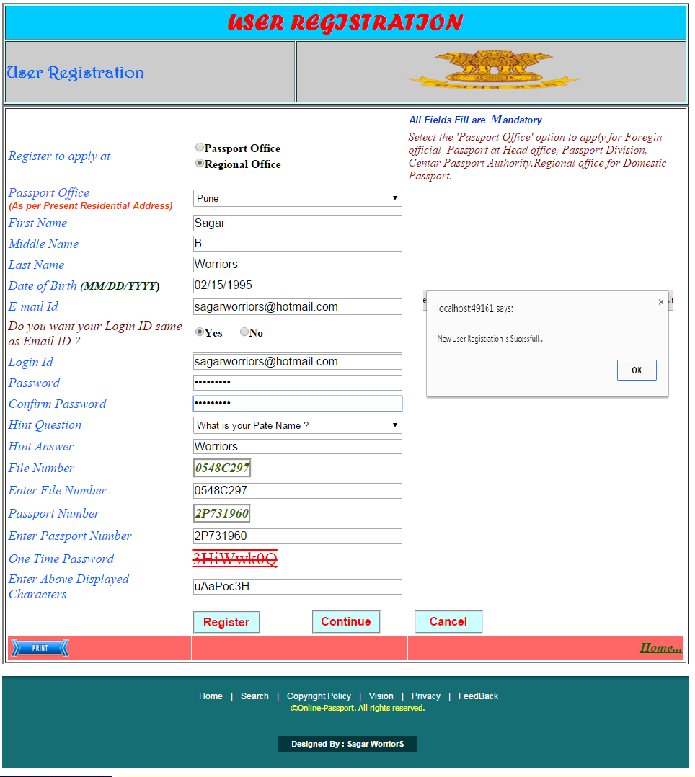

**Pseudo Code:**

|  |  |  |  |
| --- | --- | --- | --- |
| **Sr. No.** | **Name** | **Procedure** | **Description** |
| 1 | Register | Click | Used to Submit in the form. |
| 2 | Continue | Click | Used to Go next form |
| 3 | Cancel | Click | Used to Cancel in the form |
| 4 | Print | Click | Used to Print the form |

**Source Code :**

<%@ Page Title="" Language="C#" MasterPageFile="~/Home2.master" AutoEventWireup="true" CodeFile="NewUserRegistration.aspx.cs" Inherits="NewRegistration" %>

<asp:Content ID="Content1" ContentPlaceHolderID="ContentPlaceHolder1" Runat="Server">

<html>

<head>

<title>New User Registration</title>

<script type = "text/javascript">

function PrintPanel() {

var panel = document.getElementById("<%=pnlContents.ClientID %>");

var printWindow = window.open('', '', 'height=400,width=800');

printWindow.document.write('<html><head><title>DIV Contents</title>');

printWindow.document.write('</head><body >');

printWindow.document.write(panel.innerHTML);

printWindow.document.write('</body></html>');

printWindow.document.close();

setTimeout(function () {

printWindow.print();

}, 500);

return false;

}

</script>

</head>

<body>

<form id="form1" runat="server">

<asp:Panel id="pnlContents" runat = "server">

<table class="style3" border="2">

<tr><td colspan=2 class="style50"><span class="style51"><strong>USER REGISTRATION</strong></span><br /></td></tr>

<tr>

<td class="style58" style="font-size: xx-large">

<span class="style76"><strong>User Registration</strong></span></strong></blink></strong></td>

<td class="style49">

&nbsp;&nbsp;

<asp:Image ID="Image1" runat="server" Height="54px" Width="243px"

ImageUrl="~/Images1/satyamevjayate.gif" />

<br />

</td>

</tr>

</table>

<div>

<table border="2">

<tr>

<td>

<table class="style1" >

<tr>

<td class="style20"></td>

<td class="style19"></td>

<td class="style65">

<span class="style18"style="font-family: Arial, Helvetica, sans-serif; font-variant: normal; font-weight: normal; letter-spacing: normal; line-height: 20px; orphans: auto; text-align: right; text-indent: 0px; text-transform: none; white-space: normal; widows: 1; word-spacing: 0px; -webkit-text-stroke-width: 0px; display: inline !important; float: none; background-color: rgb(255, 255, 255);">

<em><strong>All Fields Fill are&nbsp; </strong></em></span><span class="style44"><em><strong>M</strong></em></span><span class="style18"

style="font-family: Arial, Helvetica, sans-serif; font-style: normal; font-variant: normal; font-weight: normal; letter-spacing: normal; line-height: 20px; orphans: auto; text-align: right; text-indent: 0px; text-transform: none; white-space: normal; widows: 1; word-spacing: 0px; -webkit-text-stroke-width: 0px; display: inline !important; float: none; background-color: rgb(255, 255, 255);"><em><strong>andatory<br />

</strong>

</em></span>

</td>

</tr>

<tr>

<td class="style24">

<span class="style69"style="font-style: normal; font-variant: normal; font-weight: normal; letter-spacing: normal; line-height: normal; orphans: auto; text-align: left; text-indent: 0px; text-transform: none; white-space: normal; widows: 1; word-spacing: 0px; -webkit-text-stroke-width: 0px; display: inline !important; float: none; background-color: rgb(255, 255, 255);">

<em>Register to apply at</em></span><span class="style14"

style="color: rgb(0, 0, 0); font-style: normal; font-variant: normal; font-weight: normal; letter-spacing: normal; line-height: normal; orphans: auto; text-align: left; text-indent: 0px; text-transform: none; white-space: normal; widows: 1; word-spacing: 0px; -webkit-text-stroke-width: 0px; display: inline !important; float: none; background-color: rgb(255, 255, 255);">

</span>

</td>

<td class="style11">

<asp:RadioButtonList ID="rdbRegister_Apply" runat="server"

style="font-weight: 700; font-size: large;">

<asp:ListItem>Passport Office</asp:ListItem>

<asp:ListItem Value="CPV Office">Regional Office</asp:ListItem>

</asp:RadioButtonList></td>

<td><span class="style6"

style="font-style: normal; font-variant: normal; font-weight: normal; letter-spacing: normal; line-height: normal; orphans: auto; text-align: start; text-indent: 0px; text-transform: none; white-space: normal; widows: 1; word-spacing: 0px; -webkit-text-stroke-width: 0px; display: inline !important; float: none; background-color: rgb(255, 255, 255);">

<em>Select the 'Passport Office' option to apply for Foregin official&nbsp; Passport at Head office, Passport Division, Centar Passport Authority.Regional office for Domestic Passport.</em></span></td>

</tr>

<tr>

<td class="style45">

<span class="style70" style="font-style: normal; font-variant: normal; font-weight: normal; letter-spacing: normal; line-height: normal; orphans: auto; text-align: start; text-indent: 0px; text-transform: none; white-space: normal; widows: 1; word-spacing: 0px; -webkit-text-stroke-width: 0px; display: inline !important; float: none; background-color: rgb(255, 255, 255);">

<em>Passport Office</em></span><span class="style14"

style="color: rgb(0, 0, 0); font-style: normal; font-variant: normal; font-weight: normal; letter-spacing: normal; line-height: normal; orphans: auto; text-align: start; text-indent: 0px; text-transform: none; white-space: normal; widows: 1; word-spacing: 0px; -webkit-text-stroke-width: 0px; display: inline !important; float: none; background-color: rgb(255, 255, 255);"><strong>

</strong></span>

<span style="color: rgb(0, 0, 0); font-family: Arial, Helvetica, sans-serif; font-size: 13px; font-style: normal; font-variant: normal; font-weight: normal; letter-spacing: normal; line-height: normal; orphans: auto; text-align: start; text-indent: 0px; text-transform: none; white-space: normal; widows: 1; word-spacing: 0px; -webkit-text-stroke-width: 0px; display: inline !important; float: none; background-color: rgb(255, 255, 255);">

<strong>

<br />

</strong><span class="style68" style="font-family: Arial, Helvetica, sans-serif; font-style: normal; font-variant: normal; font-weight: normal; letter-spacing: normal; line-height: normal; orphans: auto; text-align: start; text-indent: 0px; text-transform: none; white-space: normal; widows: 1; word-spacing: 0px; -webkit-text-stroke-width: 0px; display: inline !important; float: none; background-color: rgb(255, 255, 255);">

<em><strong>(As per Present Residential Address)</strong></em></span></span></td>

<td class="style46">

<asp:DropDownList ID="ddlPassportOffice" runat="server"

Height="24px" Width="290px">

<asp:ListItem>Select</asp:ListItem>

<asp:ListItem>Ahemdabad</asp:ListItem>

<asp:ListItem>Banglore</asp:ListItem>

<asp:ListItem>Bareilly</asp:ListItem>

<asp:ListItem>Bhopal</asp:ListItem>

<asp:ListItem>Bhuavneshwar</asp:ListItem>

<asp:ListItem>Chandigarth</asp:ListItem>

<asp:ListItem>Chennai</asp:ListItem>

<asp:ListItem>Cochin</asp:ListItem>

<asp:ListItem>Coimbatore</asp:ListItem>

<asp:ListItem>Deharadun</asp:ListItem>

<asp:ListItem>Delhi</asp:ListItem>

<asp:ListItem>Gaziyabad</asp:ListItem>

<asp:ListItem>Mumbai</asp:ListItem>

<asp:ListItem>Pune</asp:ListItem>

<asp:ListItem>Thane</asp:ListItem>

</asp:DropDownList>

</td>

<td class="style47">

<span class="style14" style="color: rgb(0, 0, 0); font-style: normal; font-variant: normal; font-weight: normal; letter-spacing: normal; line-height: normal; orphans: auto; text-align: left; text-indent: 0px; text-transform: none; white-space: normal; widows: 1; word-spacing: 0px; -webkit-text-stroke-width: 0px; display: inline !important; float: none; background-color: rgb(255, 255, 255);">

<em>

<asp:RequiredFieldValidator ID="rfvddlPassportOffice" runat="server"

CssClass="style48" ErrorMessage="* Please Select Passport Office" ControlToValidate="ddlPassportOffice"></asp:RequiredFieldValidator>

</em>

</span>

</td>

</tr>

<tr>

<td class="style38">

<span class="style69" style="font-style: normal; font-variant: normal; font-weight: normal; letter-spacing: normal; line-height: normal; orphans: auto; text-align: start; text-indent: 0px; text-transform: none; white-space: normal; widows: 1; word-spacing: 0px; -webkit-text-stroke-width: 0px; display: inline !important; float: none; background-color: rgb(255, 255, 255);">

<em>First Name</em></span><span class="style14"

style="color: rgb(0, 0, 0); font-style: normal; font-variant: normal; font-weight: normal; letter-spacing: normal; line-height: normal; orphans: auto; text-align: start; text-indent: 0px; text-transform: none; white-space: normal; widows: 1; word-spacing: 0px; -webkit-text-stroke-width: 0px; display: inline !important; float: none; background-color: rgb(255, 255, 255);"><strong>

</strong></span>

</td>

<td class="style34">

<asp:TextBox ID="txtFirstName" runat="server" Height="23px" Width="290px"></asp:TextBox>

</td>

<td class="style35">

<span class="style14" style="color: rgb(0, 0, 0); font-style: normal; font-variant: normal; font-weight: normal; letter-spacing: normal; line-height: normal; orphans: auto; text-align: left; text-indent: 0px; text-transform: none; white-space: normal; widows: 1; word-spacing: 0px; -webkit-text-stroke-width: 0px; display: inline !important; float: none; background-color: rgb(255, 255, 255);">

<em>

<asp:RequiredFieldValidator ID="rfvtxtFirstName" runat="server"

CssClass="style48" ErrorMessage="* Please Enter your First Name."

ControlToValidate="txtFirstName"></asp:RequiredFieldValidator>

</em>

</span>

</td>

</tr>

<tr>

<td class="style67">

<span class="style71" style="font-style: normal; font-variant: normal; letter-spacing: normal; line-height: normal; orphans: auto; text-align: start; text-indent: 0px; text-transform: none; white-space: normal; widows: 1; word-spacing: 0px; -webkit-text-stroke-width: 0px; display: inline !important; float: none; background-color: rgb(255, 255, 255);">

<em>Middle Name</em></span><span class="style66"

style="color: rgb(0, 0, 0); font-style: normal; font-variant: normal; letter-spacing: normal; line-height: normal; orphans: auto; text-align: start; text-indent: 0px; text-transform: none; white-space: normal; widows: 1; word-spacing: 0px; -webkit-text-stroke-width: 0px; display: inline !important; float: none; background-color: rgb(255, 255, 255);">

</span>

</td>

<td class="style34">

<asp:TextBox ID="txtMiddleName" runat="server" Height="22px" Width="290px"></asp:TextBox>

</td>

<td class="style35">

&nbsp;</td>

</tr>

<tr>

<td class="style72">

<span class="style28" style="font-variant: normal; line-height: normal; orphans: auto; text-align: start; text-indent: 0px; white-space: normal; widows: 1; word-spacing: 0px; -webkit-text-stroke-width: 0px; display: inline !important; float: none; background-color: rgb(255, 255, 255);">

<em>Last Name</em></span></td>

<td class="style34">

<asp:TextBox ID="txtLastName" runat="server" Height="22px" Width="290px"></asp:TextBox>

</td>

<td class="style35">

<span class="style14"style="color: rgb(0, 0, 0); font-style: normal; font-variant: normal; font-weight: normal; letter-spacing: normal; line-height: normal; orphans: auto; text-align: left; text-indent: 0px; text-transform: none; white-space: normal; widows: 1; word-spacing: 0px; -webkit-text-stroke-width: 0px; display: inline !important; float: none; background-color: rgb(255, 255, 255);">

<em>

<asp:RequiredFieldValidator ID="rfvtxtLastName" runat="server"

CssClass="style48" ErrorMessage="* Please Enter your Last Name."

ControlToValidate="txtLastName"></asp:RequiredFieldValidator>

</em>

</span>

</td>

</tr>

<tr>

<td class="style33">

<span class="style71"

style="font-style: normal; font-variant: normal; letter-spacing: normal; line-height: normal; orphans: auto; text-align: start; text-indent: 0px; text-transform: none; white-space: normal; widows: 1; word-spacing: 0px; -webkit-text-stroke-width: 0px; display: inline !important; float: none; background-color: rgb(255, 255, 255);">

<em>Date of Birth</em></span><span class="style66"

style="color: rgb(0, 0, 0); font-style: normal; font-variant: normal; letter-spacing: normal; line-height: normal; orphans: auto; text-align: start; text-indent: 0px; text-transform: none; white-space: normal; widows: 1; word-spacing: 0px; -webkit-text-stroke-width: 0px; display: inline !important; float: none; background-color: rgb(255, 255, 255);">

</span><span class="style73"

style="font-style: normal; font-variant: normal; letter-spacing: normal; line-height: normal; orphans: auto; text-align: start; text-indent: 0px; text-transform: none; white-space: normal; widows: 1; word-spacing: 0px; -webkit-text-stroke-width: 0px; display: inline !important; float: none; background-color: rgb(255, 255, 255);">

<em>(MM/DD/YYYY</em></span><span class="style66"

style="color: rgb(0, 0, 0); font-style: normal; font-variant: normal; letter-spacing: normal; line-height: normal; orphans: auto; text-align: start; text-indent: 0px; text-transform: none; white-space: normal; widows: 1; word-spacing: 0px; -webkit-text-stroke-width: 0px; display: inline !important; float: none; background-color: rgb(255, 255, 255);">)

</span>

</td>

<td class="style34">

<asp:TextBox ID="txtDateofBirth" runat="server" Height="22px" Width="290px"></asp:TextBox>

</td>

<td class="style35">

<span class="style14"

style="color: rgb(0, 0, 0); font-style: normal; font-variant: normal; font-weight: normal; letter-spacing: normal; line-height: normal; orphans: auto; text-align: left; text-indent: 0px; text-transform: none; white-space: normal; widows: 1; word-spacing: 0px; -webkit-text-stroke-width: 0px; display: inline !important; float: none; background-color: rgb(255, 255, 255);">

<em>

<asp:RequiredFieldValidator ID="rfvtxtDateofBirth" runat="server"

CssClass="style48" ErrorMessage="* Please Enter your Valid Date of Birth "ControlToValidate="txtDateofBirth"></asp:RequiredFieldValidator>

</em>

</span>

</td>

</tr>

<tr>

<td class="style74">

<span class="style69"

style="font-style: normal; font-variant: normal; letter-spacing: normal; line-height: normal; orphans: auto; text-align: start; text-indent: 0px; text-transform: none; white-space: normal; widows: 1; word-spacing: 0px; -webkit-text-stroke-width: 0px; display: inline !important; float: none; background-color: rgb(255, 255, 255);">

<em>E-mail Id</em></span></td>

<td class="style34">

<asp:TextBox ID="txtEmail_ID" runat="server" Height="23px" Width="290px"></asp:TextBox>

</td>

<td class="style35">

<asp:RegularExpressionValidator ID="RegularExpressionValidator1" runat="server"

ControlToValidate="txtEmail_ID" ErrorMessage="##"

ValidationExpression="\w+([-+.']\w+)*@\w+([-.]\w+)*\.\w+([-.]\w+)*"></asp:RegularExpressionValidator>

<span class="style14"

style="color: rgb(0, 0, 0); font-style: normal; font-variant: normal; font-weight: normal; letter-spacing: normal; line-height: normal; orphans: auto; text-align: left; text-indent: 0px; text-transform: none; white-space: normal; widows: 1; word-spacing: 0px; -webkit-text-stroke-width: 0px; display: inline !important; float: none; background-color: rgb(255, 255, 255);">

<em>

<asp:RequiredFieldValidator ID="rfvtxtEmail_ID" runat="server"

CssClass="style48" ErrorMessage="* Enter your Valid Email ID"

ControlToValidate="txtEmail_ID"></asp:RequiredFieldValidator>

</em>

</span>

</td>

</tr>

<tr>

<td class="style21">

<em>Do you want your Login ID same as Email ID ?</em></td>

<td class="style29">

<asp:RadioButtonList ID="rdblLoginSame_Yes_No" runat="server"

AutoPostBack="True" RepeatDirection="Horizontal" onselectedindexchanged="rdblLoginSame_Yes_No_SelectedIndexChanged"

style="font-weight: 700; font-size: large;" Height="29px" Width="120px">

<asp:ListItem>Yes</asp:ListItem>

<asp:ListItem>No</asp:ListItem>

</asp:RadioButtonList>

</td>

<td class="style30">

<span class="style14"

style="color: rgb(0, 0, 0); font-style: normal; font-variant: normal; font-weight: normal; letter-spacing: normal; line-height: normal; orphans: auto; text-align: left; text-indent: 0px; text-transform: none; white-space: normal; widows: 1; word-spacing: 0px; -webkit-text-stroke-width: 0px; display: inline !important; float: none; background-color: rgb(255, 255, 255);">

<em>

<asp:RequiredFieldValidator ID="rfvrdblLoginSame_Yes_No" runat="server" CssClass="style48" ErrorMessage="* Checked Any one Option" ControlToValidate="rdblLoginSame_Yes_No"></asp:RequiredFieldValidator>

</em>

</span>

</td>

</tr>

<tr>

<td class="style74">

<span class="style69"

style="font-style: normal; font-variant: normal; letter-spacing: normal; line-height: normal; orphans: auto; text-align: start; text-indent: 0px; text-transform: none; white-space: normal; widows: 1; word-spacing: 0px; -webkit-text-stroke-width: 0px; display: inline !important; float: none; background-color: rgb(255, 255, 255);">

<em>Login Id </em></span>

</td>

<td class="style34">

<strong>

<asp:TextBox ID="txtLoginId" runat="server" Height="22px" Width="290px"

></asp:TextBox>

</strong>

</td>

<td class="style35">

<strong><span class="style14"

style="color: rgb(0, 0, 0); font-style: normal; font-variant: normal; font-weight: normal; letter-spacing: normal; line-height: normal; orphans: auto; text-align: left; text-indent: 0px; text-transform: none; white-space: normal; widows: 1; word-spacing: 0px; -webkit-text-stroke-width: 0px; display: inline !important; float: none; background-color: rgb(255, 255, 255);">

<em>

<asp:RequiredFieldValidator ID="rfvtxtLoginId" runat="server"

CssClass="style48" ErrorMessage="* Enter Valid Login ID"

ControlToValidate="txtLoginId"></asp:RequiredFieldValidator>

</em>

</span></strong>

</td>

</tr>

<tr>

<td class="style74">

<span class="style69" style="font-style: normal; font-variant: normal; letter-spacing: normal; line-height: normal; orphans: auto; text-align: start; text-indent: 0px; text-transform: none; white-space: normal; widows: 1; word-spacing: 0px; -webkit-text-stroke-width: 0px; display: inline !important; float: none; background-color: rgb(255, 255, 255);">

<em>Password </em></span>

</td>

<td class="style34">

<asp:TextBox ID="txtPassword" runat="server" Height="22px" Width="290px"

TextMode="Password"></asp:TextBox>

</td>

<td class="style35">

<span class="style14"

style="color: rgb(0, 0, 0); font-style: normal; font-variant: normal; font-weight: normal; letter-spacing: normal; line-height: normal; orphans: auto; text-align: left; text-indent: 0px; text-transform: none; white-space: normal; widows: 1; word-spacing: 0px; -webkit-text-stroke-width: 0px; display: inline !important; float: none; background-color: rgb(255, 255, 255);">

<em>

<asp:RequiredFieldValidator ID="rfvPassword" runat="server"

CssClass="style48" ErrorMessage="* Enter Password"

ControlToValidate="txtPassword"></asp:RequiredFieldValidator>

</em>

</span>

</td>

</tr>

<tr>

<td class="style74">

<span class="style69"

style="font-style: normal; font-variant: normal; letter-spacing: normal; line-height: normal; orphans: auto; text-align: start; text-indent: 0px; text-transform: none; white-space: normal; widows: 1; word-spacing: 0px; -webkit-text-stroke-width: 0px; display: inline !important; float: none; background-color: rgb(255, 255, 255);">

<em>Confirm Password </em></span>

</td>

<td class="style34">

<asp:TextBox ID="txtConfirm_Password" runat="server" Height="22px"

Width="290px" TextMode="Password"></asp:TextBox>

</td>

<td class="style35">

<span class="style14"

style="color: rgb(0, 0, 0); font-style: normal; font-variant: normal; font-weight: normal; letter-spacing: normal; line-height: normal; orphans: auto; text-align: left; text-indent: 0px; text-transform: none; white-space: normal; widows: 1; word-spacing: 0px; -webkit-text-stroke-width: 0px; display: inline !important; float: none; background-color: rgb(255, 255, 255);">

<asp:RequiredFieldValidator ID="rfvtxtConfirm_Password" runat="server" CssClass="style26" ErrorMessage="* " ControlToValidate="txtConfirm_Password"></asp:RequiredFieldValidator>

</span>

<em>

<asp:CompareValidator ID="cvCon_to_Password" runat="server"

ControlToCompare="txtPassword" ControlToValidate="txtConfirm_Password"

CssClass="style32" ErrorMessage="Password didn't Match"></asp:CompareValidator>

</em>

</td>

</tr>

<tr>

<td class="style39">

<span class="style69"

style="font-style: normal; font-variant: normal; letter-spacing: normal; line-height: normal; orphans: auto; text-align: start; text-indent: 0px; text-transform: none; white-space: normal; widows: 1; word-spacing: 0px; -webkit-text-stroke-width: 0px; display: inline !important; float: none; background-color: rgb(255, 255, 255);">

<em>Hint Question</em></span></td>

<td class="style40">

<asp:DropDownList ID="ddlHintQuestion" runat="server"

Height="24px" Width="290px">

<asp:ListItem>What is Your Mother name ?</asp:ListItem>

<asp:ListItem>What is your Pate Name ?</asp:ListItem>

<asp:ListItem>What is your Birth Place ?</asp:ListItem>

<asp:ListItem>Where are your Native place ?</asp:ListItem>

</asp:DropDownList>

</td>

<td class="style41">

<span class="style14"

style="color: rgb(0, 0, 0); font-style: normal; font-variant: normal; font-weight: normal; letter-spacing: normal; line-height: normal; orphans: auto; text-align: left; text-indent: 0px; text-transform: none; white-space: normal; widows: 1; word-spacing: 0px; -webkit-text-stroke-width: 0px; display: inline !important; float: none; background-color: rgb(255, 255, 255);">

<em>

<asp:RequiredFieldValidator ID="rfvddlHintQuestion" runat="server"

CssClass="style48" ErrorMessage="* Select Any one Hint Question ?" ControlToValidate="ddlHintQuestion"></asp:RequiredFieldValidator>

</em>

</span>

</td>

</tr>

<tr>

<td class="style74">

<span class="style69"

style="font-style: normal; font-variant: normal; letter-spacing: normal; line-height: normal; orphans: auto; text-align: start; text-indent: 0px; text-transform: none; white-space: normal; widows: 1; word-spacing: 0px; -webkit-text-stroke-width: 0px; display: inline !important; float: none; background-color: rgb(255, 255, 255);">

<em>Hint Answer</em></span></td>

<td class="style34">

<asp:TextBox ID="txtHintAnswer" runat="server" Height="21px" Width="290px"></asp:TextBox>

</td>

<td class="style35">

<span class="style14"

style="color: rgb(0, 0, 0); font-style: normal; font-variant: normal; font-weight: normal; letter-spacing: normal; line-height: normal; orphans: auto; text-align: left; text-indent: 0px; text-transform: none; white-space: normal; widows: 1; word-spacing: 0px; -webkit-text-stroke-width: 0px; display: inline !important; float: none; background-color: rgb(255, 255, 255);">

<em>

<asp:RequiredFieldValidator ID="rfvtxtHintAnswer" runat="server"

CssClass="style48" ErrorMessage="* Enter Hint Question Answer"

ControlToValidate="txtHintAnswer"></asp:RequiredFieldValidator>

</em>

</span>

</td>

</tr>

<tr>

<td class="style75">

<em>File Number</em></td>

<td class="style42">

<asp:Label ID="lblFileNo" runat="server" BorderStyle="Groove" Font-Bold="True"

Font-Italic="True" Font-Size="Large" ForeColor="#336600"></asp:Label>

</td>

<td class="style43">

</td>

</tr>

<tr>

<td class="style45">

<span class="style69"

style="font-style: normal; font-variant: normal; letter-spacing: normal; line-height: normal; orphans: auto; text-align: start; text-indent: 0px; text-transform: none; white-space: normal; widows: 1; word-spacing: 0px; -webkit-text-stroke-width: 0px; display: inline !important; float: none; background-color: rgb(255, 255, 255);">

<em>Enter File Number</em></span></td>

<td class="style46">

<strong>

<asp:TextBox ID="txtFileNumber" runat="server" Height="22px" Width="290px"

></asp:TextBox>

</strong>

</td>

<td class="style47">

<strong><span class="style14"

style="color: rgb(0, 0, 0); font-style: normal; font-variant: normal; font-weight: normal; letter-spacing: normal; line-height: normal; orphans: auto; text-align: left; text-indent: 0px; text-transform: none; white-space: normal; widows: 1; word-spacing: 0px; -webkit-text-stroke-width: 0px; display: inline !important; float: none; background-color: rgb(255, 255, 255);">

<em>

<asp:RequiredFieldValidator ID="RequiredFieldValidator1" runat="server"

CssClass="style48" ErrorMessage="* Enter Valid File Number"

ControlToValidate="txtFileNumber"></asp:RequiredFieldValidator>

</em>

</span></strong>

</td>

</tr>

<tr>

<td class="style75">

<em>Passport Number</em></td>

<td class="style42">

<asp:Label ID="lblPassportNo" runat="server" BorderStyle="Groove"

Font-Bold="True" Font-Italic="True" Font-Size="Large" ForeColor="#336600"></asp:Label>

</td>

<td class="style43">

</td>

</tr>

<tr>

<td class="style45">

<span class="style69"

style="font-style: normal; font-variant: normal; letter-spacing: normal; line-height: normal; orphans: auto; text-align: start; text-indent: 0px; text-transform: none; white-space: normal; widows: 1; word-spacing: 0px; -webkit-text-stroke-width: 0px; display: inline !important; float: none; background-color: rgb(255, 255, 255);">

<em>Enter Passport Number</em></span></td>

<td class="style46">

<strong>

<asp:TextBox ID="txtPassportNumber" runat="server" Height="22px" Width="290px"

></asp:TextBox>

</strong>

</td>

<td class="style47">

<strong><span class="style14"

style="color: rgb(0, 0, 0); font-style: normal; font-variant: normal; font-weight: normal; letter-spacing: normal; line-height: normal; orphans: auto; text-align: left; text-indent: 0px; text-transform: none; white-space: normal; widows: 1; word-spacing: 0px; -webkit-text-stroke-width: 0px; display: inline !important; float: none; background-color: rgb(255, 255, 255);">

<em>

<asp:RequiredFieldValidator ID="RequiredFieldValidator2" runat="server"

CssClass="style48" ErrorMessage="* Enter Valid Passport Number"

ControlToValidate="txtPassportNumber"></asp:RequiredFieldValidator>

</em>

</span></strong>

</td>

</tr>

<tr>

<td class="style75">

<em>One Time Password</em></td>

<td class="style42">

<asp:Label ID="Label1" runat="server" Font-Size="X-Large" ForeColor="Red"

Font-Overline="True" Font-Strikeout="True" Font-Underline="True"></asp:Label>

</td>

<td class="style43">

</td>

</tr>

<tr>

<td class="style45">

<span class="style69"

style="font-style: normal; font-variant: normal; letter-spacing: normal; line-height: normal; orphans: auto; text-align: start; text-indent: 0px; text-transform: none; white-space: normal; widows: 1; word-spacing: 0px; -webkit-text-stroke-width: 0px; display: inline !important; float: none; background-color: rgb(255, 255, 255);">

<em>Enter Above Displayed Characters</em></span></td>

<td class="style46">

<strong>

<asp:TextBox ID="txtOTPChar" runat="server" Height="22px" Width="290px"></asp:TextBox>

</strong>

</td>

<td class="style47">

<strong><span class="style14"

style="color: rgb(0, 0, 0); font-style: normal; font-variant: normal; font-weight: normal; letter-spacing: normal; line-height: normal; orphans: auto; text-align: left; text-indent: 0px; text-transform: none; white-space: normal; widows: 1; word-spacing: 0px; -webkit-text-stroke-width: 0px; display: inline !important; float: none; background-color: rgb(255, 255, 255);">

<em>

<asp:RequiredFieldValidator ID="rfvtxtCharacter" runat="server"

CssClass="style48" ErrorMessage="* Enter Valid Character"

ControlToValidate="txtOTPChar"></asp:RequiredFieldValidator>

</em>

</span></strong>

</td>

</tr>

<tr>

<td class="style59">

</td>

<td class="style40">

<strong>

<asp:Button ID="btnRegister" runat="server" BorderStyle="Groove" CssClass="style31"

Height="31px" Text="Register" Width="93px" onclick="btnRegister_Click" /></strong>&nbsp;&nbsp;&nbsp;&nbsp;&nbsp;&nbsp;&nbsp;&nbsp;<strong><asp:Button ID="btnContinue" runat="server"

BorderStyle="Groove" CssClass="style31"

Height="32px" Text="Continue" Width="95px" onclick="btnContinue_Click" />

</strong></td>

<td class="style41">

<strong>&nbsp;<asp:Button ID="btnCancel" runat="server" BorderStyle="Groove"

CssClass="style31" Height="32px" onclick="btnCancel_Click1" Text="Cancel" Width="95px" />

</strong>

</td>

</tr>

<tr>

<td class="style57" >

<asp:ImageButton ID="btnPrint" runat="server" Height="32px"

ImageUrl="~/ImageButton/printbutton.png" Width="88px" OnClientClick = "PrintPanel()"/>

</td>

<td class="style57" >

&nbsp;</td>

<td class="style57" align="right" >

<asp:HyperLink ID="HyperLink1" runat="server" Font-Bold="True"

Font-Italic="True" Font-Size="Large" ForeColor="#006600"

NavigateUrl="~/HomePage.aspx">Home...</asp:HyperLink>

</td>

</tr>

</table>

</td></tr>

</table>

</div>

</asp:Panel>

</form>

</body>

</html>

</asp:Content>

**Code :-**

using System;

using System.Collections.Generic;

using System.Linq;

using System.Web;

using System.Web.UI;

using System.Web.UI.WebControls;

using System.Data;

using System.Data.SqlClient;

using System.Configuration;

using System.Net.Mail;

using System.Net;

public partial class NewRegistration : System.Web.UI.Page

{

SqlConnection con = new SqlConnection(ConfigurationManager.ConnectionStrings["ConnectionString"].ConnectionString);

protected void Page_Load(object sender, EventArgs e)

{

GenerateOTP();

txtConfirm_Password.Focus();

btnContinue.Visible = false;

if (IsPostBack == false)

{

PassportNumber();

FileNumber();

}

}

private void GenerateOTP()

{

// genereate OTP

string alphabets = "ABCDEFGHIJKLMNPQRSTUVWXYZ";

string small_alphabets = "abcdefghijklmnopqrstuvwxyz";

string numbers = "1234567890";

string characters = numbers;

characters += alphabets + small_alphabets + numbers;

int length = 8;

string otp = string.Empty;

for (int i = 0; i < length; i++)

{

string character = string.Empty;

do

{

int index = new Random().Next(0, characters.Length);

character = characters.ToCharArray()[index].ToString();

} while (otp.IndexOf(character) != -1);

otp += character;

}

Label1.Text = otp;

}

protected void rdblLoginSame_Yes_No_SelectedIndexChanged(object sender, EventArgs e)

{

if (rdblLoginSame_Yes_No.SelectedIndex == 0)

{

txtLoginId.Text = txtEmail_ID.Text;

// txtLoginId.Visible = false;

}

}

protected void btnCancel_Click1(object sender, EventArgs e)

{

Clear();

Response.Redirect("HomePage.aspx");

}

protected void btnRegister_Click(object sender, EventArgs e)

{

if (lblFileNo.Text != txtFileNumber.Text && lblPassportNo.Text != txtPassportNumber.Text && txtOTPChar.Text != Label1.Text )

{

Response.Write("<script>alert('Please Enter Correct File Number & Passport Number or One Time Password')</script>");

}

else

{

SqlCommand cmd = new SqlCommand("INSERT INTO NewUserRegistration (Register_Apply,Passport_Office,First_Name,Middle_Name,Last_Name,Date_of_Birth,Email_Id,Login_Id,Password,Confirm_Password,Hint_Question,Hint_Answer,File_No,Passport_No,Characters) VALUES('" + rdbRegister_Apply.Text + "','" + ddlPassportOffice.Text + "','" + txtFirstName.Text + "','" + txtMiddleName.Text + "','" + txtLastName.Text + "','" + txtDateofBirth.Text + "','" + txtEmail_ID.Text + "','" + txtLoginId.Text + "','" + txtPassword.Text + "','" + txtConfirm_Password.Text + "',' " + ddlHintQuestion.Text + " ', '" + txtHintAnswer.Text + "','" + txtFileNumber.Text + "','" + txtPassportNumber.Text + "','" + txtOTPChar.Text + "')", con

con.Open();

cmd.ExecuteNonQuery();

con.Close();

Response.Write("<script>alert('New User Registration is Sucessfull...')</script>");﻿

Session["Passport No"] = txtPassportNumber.Text;

btnContinue.Visible = true;

}

}

// clear method

public void Clear()

{

rdbRegister_Apply.SelectedIndex = -1;

ddlPassportOffice.Text = "";

txtFirstName.Text = "";

txtMiddleName.Text="";

txtLastName.Text = "";

txtDateofBirth.Text = "";

txtEmail_ID.Text = "";

rdblLoginSame_Yes_No.SelectedIndex=-1;

txtLoginId.Text = "";

txtPassword.Text = "";

txtConfirm_Password.Text = "";

txtHintAnswer.Text = "";

txtOTPChar.Text = "";

}

protected void btnContinue_Click(object sender, EventArgs e)

{

Response.Redirect("MemberLogin.aspx");

}

private void PassportNumber()

{

// genereate PassportNo

string alphabets = "PQR";

string numbers = "1234567890";

string characters = numbers;

characters += alphabets + numbers;

int length = 8;

string PassNo = string.Empty;

for (int i = 0; i < length; i++)

{

string character = string.Empty;

do

{

int index = new Random().Next(0, characters.Length);

character = characters.ToCharArray()[index].ToString();

} while (PassNo.IndexOf(character) != -1);

PassNo += character;

}

lblPassportNo.Text = PassNo;

//txtPassportNo.Text=P.Text;

}

private void FileNumber()

{

// genereate FileNumber

string alphabets = "ABC";

string numbers = "1234567890";

string characters = numbers;

characters += alphabets + numbers;

int length = 8;

string FileNo = string.Empty;

for (int i = 0; i < length; i++)

{

string character = string.Empty;

do

{

int index = new Random().Next(0, characters.Length);

character = characters.ToCharArray()[index].ToString();

} while (FileNo.IndexOf(character) != -1);

FileNo += character;

}

lblFileNo.Text = FileNo;

//txtFileNumber.Text= F.Text;

}

}

**Program Name:** FormStatus.aspx

**Program Function:** This form used for Details of All Form.



**Program Name:** UploadPhoto.aspx

**Program Function:** This form used for Upload Photo & Signature.



**Pseudo Code:**

|  |  |  |  |
| --- | --- | --- | --- |
| **Sr. No.** | **Name** | **Procedure** | **Description** |
| 1 | Save | Click | Used to submit the form. |
| 2 | Display | Click | Used to DisplayPhoto & Sign |
| 3 | Continue | Click | Used to Go to Next Form |

**Code :-**

using System;

using System.Collections.Generic;

using System.Linq;

using System.Web;

using System.Web.UI;

using System.Web.UI.WebControls;

using System.Data;

using System.Data.SqlClient;

using System.Configuration;

public partial class UploadPhoto : System.Web.UI.Page

{

SqlConnection con = new SqlConnection(ConfigurationManager.ConnectionStrings["ConnectionString"].ConnectionString);

protected void Page_Load(object sender, EventArgs e)

{

if (Session["UserName"] != null)

lblUser.Text = "Welcome to...! : " + Session["UserName"];

if (Session["Passport No"] != null)

lblPassportNo.Text = "Your Passport No: " + Session["Passport No"];

}

protected void btnSave_Click(object sender, EventArgs e)

{

con.Open();

string query = "Select userId from NewUserRegistration where Login_id='" + Session["Username"] + "' ";

SqlDataAdapter sa = new SqlDataAdapter(query, con);

DataTable dt = new DataTable();

sa.Fill(dt);

int userid = Convert.ToInt32(dt.Rows[0][0]);

byte[] image_Byte = new byte[FileUpload1.PostedFile.InputStream.Length + 1];

FileUpload1.PostedFile.InputStream.Read(image_Byte, 0, image_Byte.Length);

byte[] sign_Byte = new byte[FileUpload2.PostedFile.InputStream.Length + 1];

FileUpload2.PostedFile.InputStream.Read(sign_Byte, 0, sign_Byte.Length);

//Check whether image size 25 kb and signature size 12 kb or not

long size_img = FileUpload1.PostedFile.InputStream.Length;

long size_sign = FileUpload2.PostedFile.InputStream.Length;

SqlCommand cmd = new SqlCommand("INSERT INTO UploadImageSign (userID,image,sign) VALUES('" + userid + "','" + image_Byte + "','" + sign_Byte + "')", con);

lblMessage.Text = "Photo & Sign Save Successfully...";

con.Close();

Response.Write("<script>alert('Your Photo And Signature has Successfull Save')</script>");﻿

}

protected void btnDispaly_Click(object sender, EventArgs e)

{

Retrieve_Image_signFromDB();

Response.Write("<script>alert('Click on Continue Button for go to Next Page..')</script>");﻿

}

private void Retrieve_Image_signFromDB()

{

Image1.ImageUrl = "image.aspx";

Image2.ImageUrl = "sign.aspx";

}

protected void btnContinue_Click(object sender, EventArgs e)

{

Response.Redirect("FormStatus.aspx");

}

}

**image.aspx :**

using System;

using System.Collections.Generic;

using System.Linq;

using System.Web;

using System.Web.UI;

using System.Web.UI.WebControls;

using System.Data;

using System.Data.SqlClient;

using System.Configuration;

public partial class image : System.Web.UI.Page

{

protected void Page_Load(object sender, EventArgs e)

{

SqlConnection con = new SqlConnection(ConfigurationManager.ConnectionStrings["ConnectionString"].ConnectionString);

con.Open();

SqlCommand cmd = new SqlCommand("select image from UploadImageSign where userId = '" + Session["Username"] + "' ", con);

SqlDataReader dr = cmd.ExecuteReader();

if (dr.Read())

{

Response.BinaryWrite((byte[])dr["image"]);

}

con.Close();

}

}

**sign.aspx**

using System;

using System.Collections.Generic;

using System.Linq;

using System.Web;

using System.Web.UI;

using System.Web.UI.WebControls;

using System.Data;

using System.Data.SqlClient;

using System.Configuration;

public partial class sign : System.Web.UI.Page

{

protected void Page_Load(object sender, EventArgs e)

{

SqlConnection con = new SqlConnection(ConfigurationManager.ConnectionStrings["ConnectionString"].ConnectionString);

con.Open();

SqlCommand cmd = new SqlCommand("select sign from UploadImageSign where userId = '" + Session["Username"] + "' ", con);

SqlDataReader dr = cmd.ExecuteReader();

if (dr.Read())

{

Response.BinaryWrite((byte[])dr["sign"]);

}

con.Close();

}

}

**Program Name:**PassportApplication.aspx

**Program Function:** This form used for Apply for Passport.

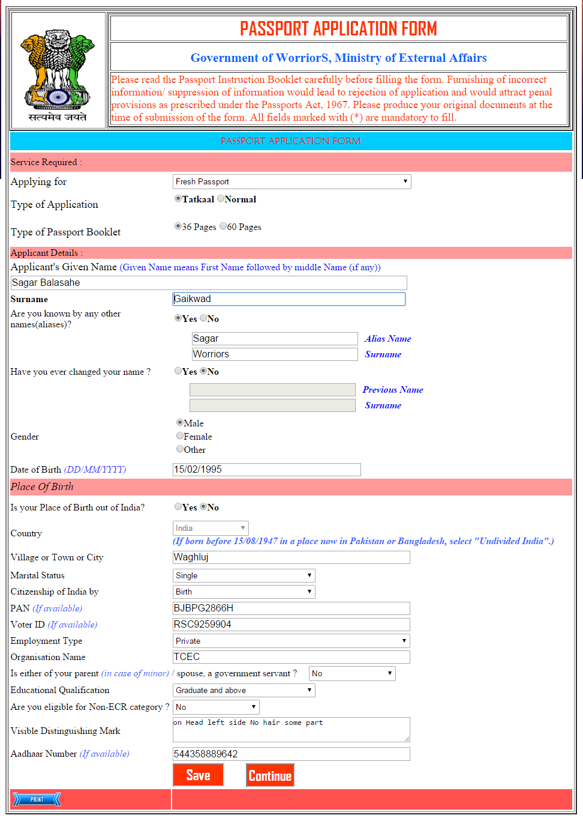

**Pseudo Code:**

|  |  |  |  |
| --- | --- | --- | --- |
| **Sr. No.** | **Name** | **Procedure** | **Description** |
| 1 | Save | Click | Used to Save the Form. |
| 2 | Continue | Click | Used to go to Next Form. |

**Code :-**

using System;

using System.Collections.Generic;

using System.Linq;

using System.Web;

using System.Web.UI;

using System.Web.UI.WebControls;

using System.Data;

using System.Data.SqlClient;

using System.Configuration;

public partial class PassportApplicationForm1 : System.Web.UI.Page

{

SqlConnection con = new SqlConnection(ConfigurationManager.ConnectionStrings["ConnectionString"].ConnectionString);

protected void Page_Load(object sender, EventArgs e)

{

txtApplicantSurname.Focus();

btnContinue.Visible = false;

}

protected void btnSave_Click(object sender, EventArgs e)

{

string query = "Select userId from NewUserRegistration where Login_id='"+Session["Username"]+"' ";

SqlDataAdapter sa = new SqlDataAdapter(query, con);

DataTable dt = new DataTable();

sa.Fill(dt);

int userid = Convert.ToInt32(dt.Rows[0][0]);

SqlCommand cmd = new SqlCommand("INSERT INTO PassportApplicationForm1 (userID,Applying_for,Type_of_Application,Passport_Booklet,Applicant_Name,Applicant_Surname,Other_NamesYes_No,Alias_Name,Alias_Surname,changed_NameYes_No,Previous_Name,Previous_Surname,Gender,Date_of_Birth,Birth_out_of_India,Country,Village_Town_City,Marital_Status,Citizenship_India_by,PAN,VoterID,Employment_Type,Organisation_Name,Parent_government_servant,Educational_Qualification,eligible_Non_ECR_category,Visible_DistMark,Aadhaar_Number ) VALUES('" + userid + "','" + ddlServiceapply.Text + "','" + rdblTypesofAPP.Text + "','" + rdblPassBooklet.Text + "','" + txtApplicantName.Text + "','" + txtApplicantSurname.Text + "','" + rblOtherNames.Text + "','" + txtOtherAliasNames.Text + "','" + txtOtherAliasSurname.Text + "','" + rblChangedName.Text + "','" + txtChangedNames.Text + "','" + txtChangedSurname.Text + "','" + rdbGender.Text + "','" + txtDateofBirth.Text + "','" + rblBirth_out_of_India.Text + "','" + ddlCountryOutIndia.Text + "','" + txtVillage_Town_City.Text + "','" + ddlMaritalStatus.Text + "','" + ddlCitizenshipInd.Text + "','" + txtPan.Text + "','" + txtVoterID.Text + "','" + ddlEmploymentType.Text + "','" + txtOrganisation.Text + "','" + ddlMinorGovServnt.Text + "','" + ddlEduQualification.Text + "','" + ddlNonECR.Text + "','" + txtVisibleDistMark.Text + "','" + txtAadharNum.Text + "')", con);

con.Open();

try

{

cmd.ExecuteNonQuery();

con.Close();

Response.Write("<script>alert('Data is Sucessfull Save Into DataBase')</script>");﻿

btnContinue.Visible = true;

}

catch (Exception ea)

{

Response.Write(ea.Message);

}

}

protected void btnContinue_Click(object sender, EventArgs e)

{

Response.Redirect("PassportApplicationForm2.aspx");

}

protected void btnCancel_Click(object sender, EventArgs e)

{

Response.Write("<script lang='javascript'>alert('Do you want to cancel it...?');</script>");

}

protected void rblOtherNames_SelectedIndexChanged(object sender, EventArgs e)

{

if (rblOtherNames.SelectedIndex == 0)

{

txtOtherAliasNames.Enabled = true;

txtOtherAliasSurname.Enabled = true;

}

else

{

txtOtherAliasNames.Enabled = false;

txtOtherAliasSurname.Enabled = false;

}

}

protected void rblChangedName_SelectedIndexChanged(object sender, EventArgs e)

{

if (rblChangedName.SelectedIndex == 0)

{

txtChangedNames.Enabled = true;

txtChangedSurname.Enabled = true;

}

else

{

txtChangedNames.Enabled = false;

txtChangedSurname.Enabled = false;

}

}

protected void rblBirth_out_of_India_SelectedIndexChanged(object sender, EventArgs e)

{

if (rblBirth_out_of_India.SelectedIndex == 0)

{

ddlCountryOutIndia.Enabled = true;

}

else

{

ddlCountryOutIndia.Enabled = false;

}

}

protected void ImageButton3_Click(object sender, ImageClickEventArgs e)

{

Response.Redirect("FormStatus.aspx");

}

}

**Program Name :**PassportApplication.aspx

**Program Function:** This form used for Apply for Passport.

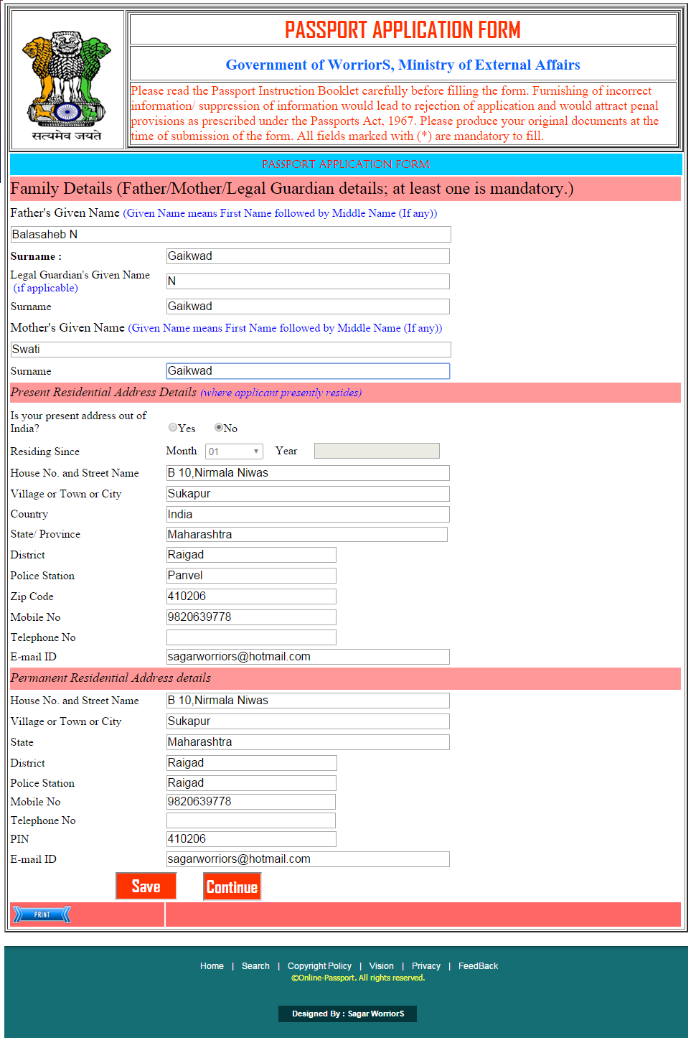

**Pseudo Code:**

|  |  |  |  |
| --- | --- | --- | --- |
| **Sr. No.** | **Name** | **Procedure** | **Description** |
| 1 | Save | Click | Used to Save the Form. |
| 2 | Continue | Click | Used to go to Form Status Form. |

**Code :-**

using System;

using System.Collections.Generic;

using System.Linq;

using System.Web;

using System.Web.UI;

using System.Web.UI.WebControls;

using System.Data;

using System.Data.SqlClient;

using System.Configuration;

public partial class PassportApplicationForm2 : System.Web.UI.Page

{

SqlConnection con = new SqlConnection(ConfigurationManager.ConnectionStrings["ConnectionString"].ConnectionString);

protected void Page_Load(object sender, EventArgs e)

{

txtMotherSurname.Focus();

btnContinue.Visible = false;

}

protected void btnSave_Click(object sender, EventArgs e)

{

string query = "Select userId from NewUserRegistration where Login_id='" + Session["Username"] + "' ";

SqlDataAdapter sa = new SqlDataAdapter(query, con);

DataTable dt = new DataTable();

sa.Fill(dt);

int userid = Convert.ToInt32(dt.Rows[0][0]);

con.Open();

SqlCommand cmd = new SqlCommand("INSERT INTO PassportApplicationForm2 (userID,Father_Given_Name,Father_Surname,Guardian_GivenName,Guardian_Surname,Mother_Given_Name,Mother_Surname,Present_Address_outof_India,Residing_Month,Residing_Year,HouseNo_StreetName,Village_Town_City,Country,State,District,Police_Station,Zip_Code,Mobile_No,Telephone_No,EmailID,P_HouseNo_StreetName,P_VillageTownCity,P_State,P_District,P_PoliceStation,P_MobileNo,P_TelephoneNo,P_PIN,P_EmailID ) VALUES('" + userid + "','" + txtFatherName.Text + "','" + txtFatherSurname.Text + "','" + txtGaurdianLegalGivenName.Text + "','" + txtGaurdianSurname.Text + "','" + txtMotherName.Text + "','" + txtMotherSurname.Text + "','" + rblPresentAddressoutofIndia.Text + "','" + ddlResiding_Month.Text + "','" + txtResiding_Year.Text + "','" + txtHouse_Street.Text + "','" + txtVillage_Town_City.Text + "','" + txtCountry.Text + "','" + txtState_Province.Text + "','" + txtDistrict.Text + "','" + txtPolice_Station.Text + "','" + txtZip_Code.Text + "','" + txtMobile_No.Text + "','" + txtTelephone_No.Text + "','" + txtEmail_ID.Text + "','" + txtPerm_Hose_Street.Text + "','" + txtPerm_Village_Town.Text + "','" + ddlPermState.Text + "','" + txtPerm_District.Text + "','" + txtPerm_PoliceStation.Text + "','" + txtPerm_MobileNO.Text + "','" + txtPerm_Tel_No.Text + "','" + txtPerm_Pin.Text + "')", con);

try

{

cmd.ExecuteNonQuery();

con.Close();

Response.Write("<script>alert('Data is Sucessfull Save Into DataBase')</script>");﻿

btnContinue.Visible = true;

}

catch (Exception ea)

{

Response.Write(ea.Message);

}

}

protected void btnContinue_Click(object sender, EventArgs e)

{

Response.Redirect("PassportApplicationForm3.aspx");

}

protected void rblPresentAddressoutofIndia_SelectedIndexChanged(object sender, EventArgs e)

{

if (rblPresentAddressoutofIndia.SelectedIndex == 0)

{

ddlResiding_Month.Enabled = true;

txtResiding_Year.Enabled = true;

}

else

{

ddlResiding_Month.Enabled = false;

txtResiding_Year.Enabled = false;

}

}

}

**Program Name :** PoliceClearanceCertificate.aspx

**Program Function:** This form used for Apply for Police Clearance Certificate

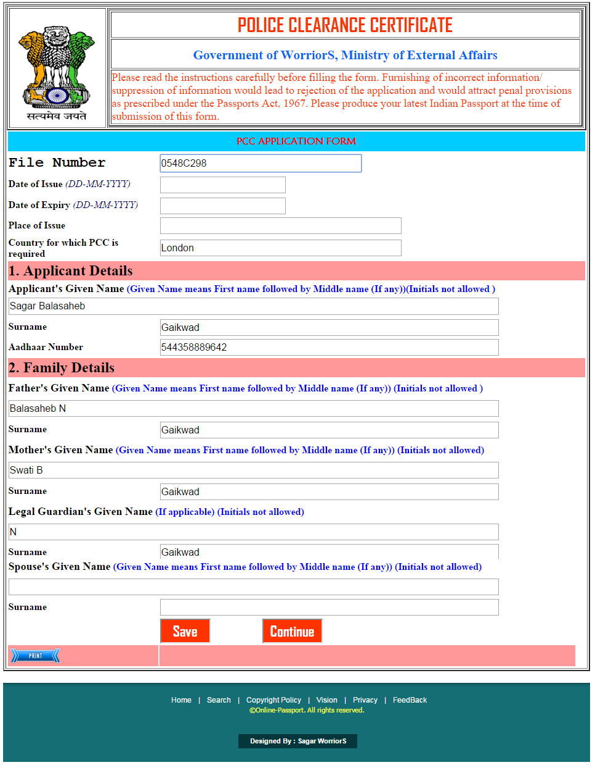

**Pseudo Code:**

|  |  |  |  |
| --- | --- | --- | --- |
| **Sr. No.** | **Name** | **Procedure** | **Description** |
| 1 | Save | Click | Used to Save the Form. |
| 2 | Continue | Click | Used to go to Next Form. |

**Code:**

using System;

using System.Collections.Generic;

using System.Linq;

using System.Web;

using System.Web.UI;

using System.Web.UI.WebControls;

using System.Data;

using System.Data.SqlClient;

using System.Configuration;

public partial class PoliceClearanceCertificateForm1 : System.Web.UI.Page

{

SqlConnection con = new SqlConnection(ConfigurationManager.ConnectionStrings["ConnectionString"].ConnectionString);

protected void Page_Load(object sender, EventArgs e)

{

txtApplicantName.Focus();

btncontinue.Visible = false;

}

protected void btnSave_Click(object sender, EventArgs e)

{

string query = "Select userId from NewUserRegistration where Login_id='" + Session["Username"] + "' ";

SqlDataAdapter sa = new SqlDataAdapter(query, con);

DataTable dt = new DataTable();

sa.Fill(dt);

int userid = Convert.ToInt32(dt.Rows[0][0]);

con.Open();

SqlCommand cmd = new SqlCommand("INSERT INTO PoliceClearanceCertificateForm1 (userID,File_Number,Date_of_Issue,Date_of_Expiry,Place_of_Issue,PCC_Required,Applicant_GivenName,Applicant_Surname,Aadhaar_Number,Father_GivenName,Father_Surname,Mother_GivenName,Mother_Surname,Guardian_GivenName,Guardian_Surname,Spouse_GivenName,Spouse_Surname) VALUES('" + userid + "','" + txtFileNumber.Text + "','" + txtDateofIssue.Text + "','" + txtDateofExpiry.Text + "','" + txtPlaceofIssue.Text + "','" + txtCountryPCCrequired.Text + "','" + txtApplicantName.Text + "','" + txtApplicantSurname.Text + "','" + txtAdharNumber.Text + "','" + txtFatherName.Text + "','" + txtFatherSurname.Text + "','" + txtMotherName.Text + "','" + txtMotherSurname.Text + "','" + txtLegalGaurdian.Text + "','" + txtGaurdianSurname.Text + "','" + txtSpouceName.Text + "','" + txtSpouceSurname.Text + "')", con);

try

{

cmd.ExecuteNonQuery();

con.Close();

Response.Write("<script>alert('Data is Sucessfull Save Into DataBase')</script>");﻿

btncontinue.Visible = true;

}

catch (Exception ea)

{

Response.Write(ea.Message);

}

}

protected void btncontinue_Click(object sender, EventArgs e)

{

Response.Redirect("PoliceClearanceCertificateForm2.aspx");

}

}

**Program Name:** LineofControlForm.aspx

**Program Function:** This form used for Apply LOC

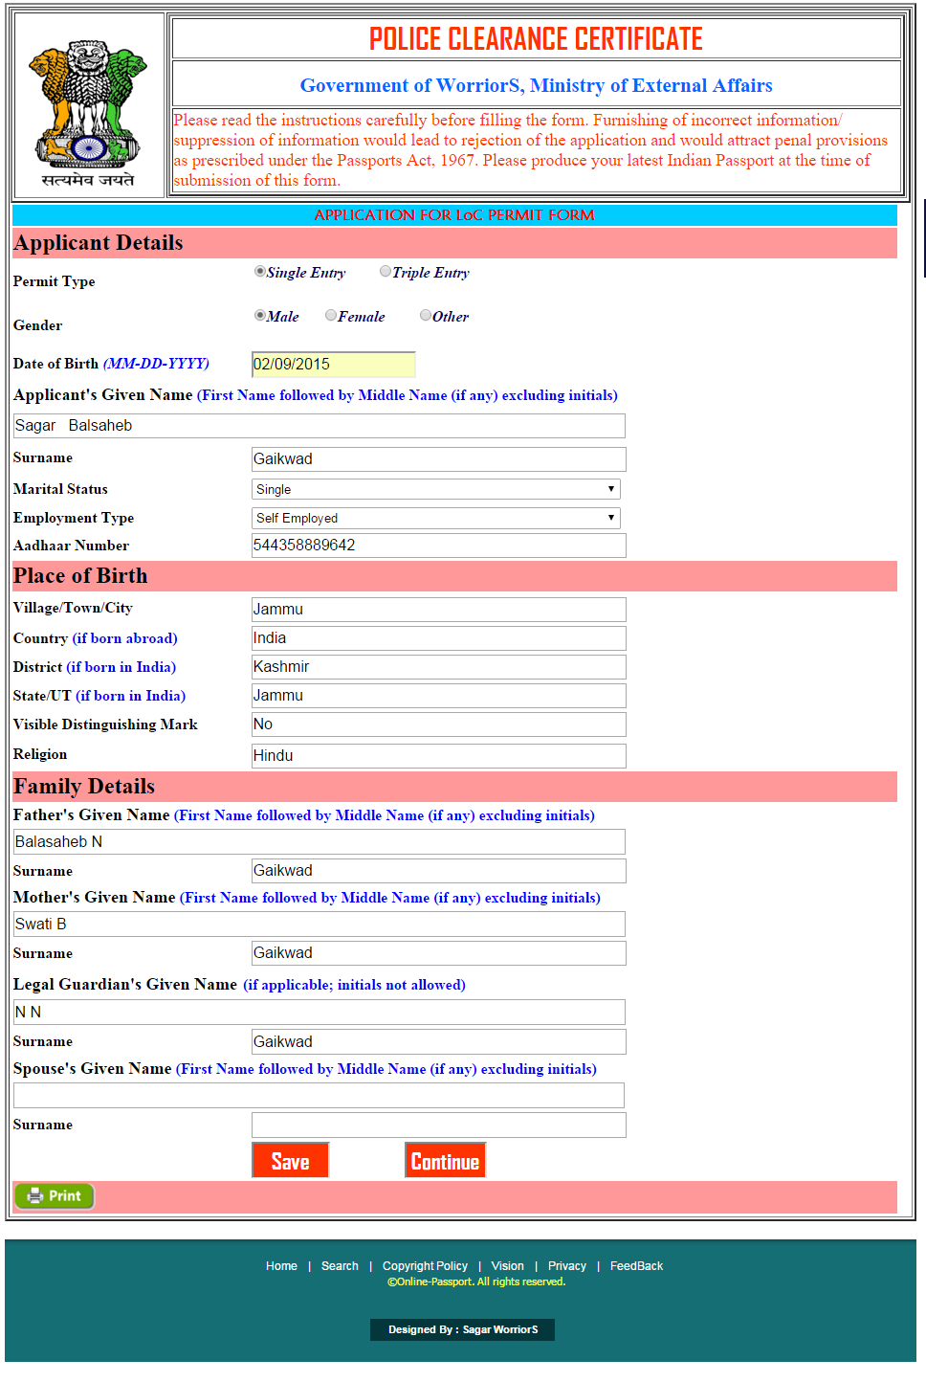

**Pseudo Code:**

|  |  |  |  |
| --- | --- | --- | --- |
| **Sr. No.** | **Name** | **Procedure** | **Description** |
| 1 | Save | Click | Used to Save the Form. |
| 2 | Continue | Click | Used to go to Next Form. |

**Code:**

using System;

using System.Collections.Generic;

using System.Linq;

using System.Web;

using System.Web.UI;

using System.Web.UI.WebControls;

using System.Data;

using System.Data.SqlClient;

using System.Configuration;

public partial class LineofControlForm1 : System.Web.UI.Page

{

SqlConnection con = new SqlConnection(ConfigurationManager.ConnectionStrings["ConnectionString"].ConnectionString);

protected void Page_Load(object sender, EventArgs e)

{

txtAdharNo.Focus();

btncontinue.Visible = false;

}

protected void btnSave_Click(object sender, EventArgs e)

{

con.Open();

string query = "Select userId from NewUserRegistration where Login_id='" + Session["Username"] + "' ";

SqlDataAdapter sa = new SqlDataAdapter(query, con);

DataTable dt = new DataTable();

sa.Fill(dt);

int userid = Convert.ToInt32(dt.Rows[0][0]);

SqlCommand cmd = new SqlCommand("INSERT INTO LineofControlForm1 (userID,Permit_Type,Gender,Date_of_Birth,Applicant_Given_Name,Applicant_Surname,Marital_Status,Employment_Type,Village_Town_City,Aadhaar_Number,Country,District,State_UT,Visible_DistMark,Religion,Father_Given_Name,Father_Surname,Mother_Given_Name,Mother_Surname,Guardian_Given_Name,Guardian_Surname,Spouse_Name,Spouse_Surname) VALUES('" + userid + "','" + rblPermitType.Text + "','" + rblGender.Text + "','" + txtDateofBirth.Text + "','" + txtApplicantGivenName.Text + "','" + txtApplicantGivenSurname.Text + "','" + ddlMaritalStatus.Text + "','" + ddlEmpType.Text + "','" + txtAdharNo.Text + "','" + txtVillage_Town_City.Text + "','" + txtCountry.Text + "','" + txtDistrict.Text + "',' " + txtState.Text + " ', '" + txtVisible.Text + "','" + txtReligion.Text + "', '" + txtFatherName.Text + "', '" + txtFatharSurname.Text + "','" + txtMotherName.Text + "','" + txtMotherSurname.Text + "','" + txtLegalGuardianName.Text + "','" + txtLegalGuardianSurname.Text + "','" + txtSpouceName.Text + "','" + txtMobileNumber10.Text + "')", con);

try

{

cmd.ExecuteNonQuery();

con.Close();

Response.Write("<script>alert('Data is Sucessfull Save Into DataBase')</script>");

btncontinue.Visible = true;

﻿

}

catch (Exception e2)

{

Response.Write(e2.Message);

}

}

protected void btncontinue_Click(object sender, EventArgs e)

{

Response.Redirect("LineofControlForm2.aspx");

}

}

**Program Name:** LineofControlForm.aspx

**Program Function:** This form used for Apply LOC

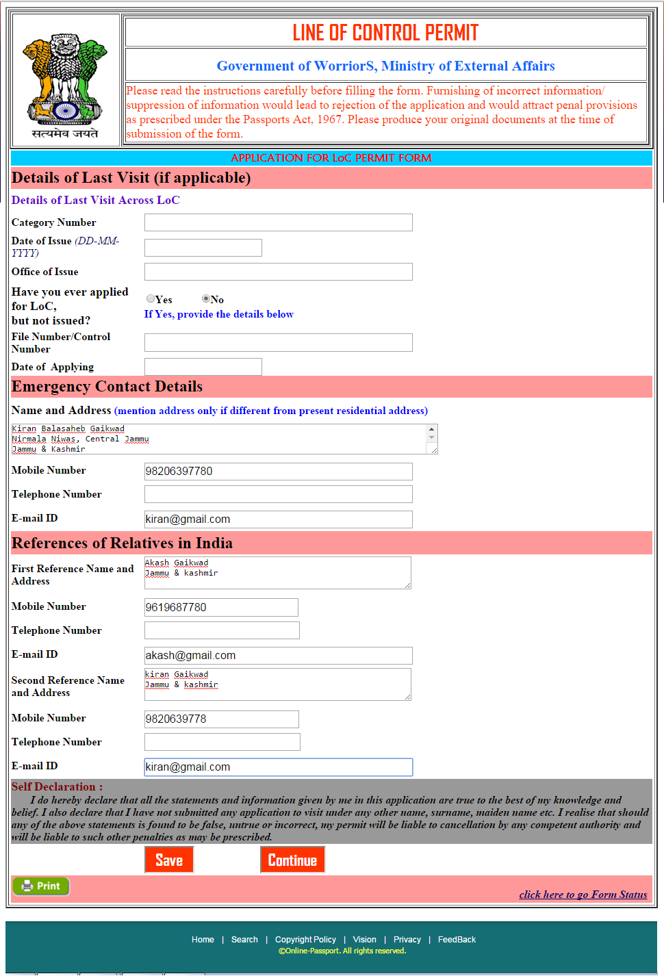

**Pseudo Code:**

|  |  |  |  |
| --- | --- | --- | --- |
| **Sr. No.** | **Name** | **Procedure** | **Description** |
| 1 | Save | Click | Used to Save the Form. |
| 2 | Continue | Click | Used to go to Next Form. |

**Code:**

using System;

using System.Collections.Generic;

using System.Linq;

using System.Web;

using System.Web.UI;

using System.Web.UI.WebControls;

using System.Data;

using System.Data.SqlClient;

using System.Configuration;

public partial class LineofControlForm3 : System.Web.UI.Page

{

SqlConnection con = new SqlConnection(ConfigurationManager.ConnectionStrings["ConnectionString"].ConnectionString);

protected void Page_Load(object sender, EventArgs e)

{

txtApplying_Date.Focus();

btnContinue.Visible = false;

}

protected void btnSave_Click1(object sender, EventArgs e)

{

con.Open();

string query = "Select userId from NewUserRegistration where Login_id='" + Session["Username"] + "' ";

SqlDataAdapter sa = new SqlDataAdapter(query, con);

DataTable dt = new DataTable();

sa.Fill(dt);

int userid = Convert.ToInt32(dt.Rows[0][0]);

SqlCommand cmd = new SqlCommand("INSERT INTO LineofControlForm3 (userID,Category_Number,Date_of_Issue,Office_of_Issue,applied_for_LoC,File_Number,Applying_Date,E_Name_Address,E_Mobile_No,E_Telephone_No,E_EmailID,FrefRelative_AcrossNameAddress,FrefRelative_AcrossMobile_No,FrefRelative_AcrossTelephone_No,FrefRelative_AcrossEmailID,SrefRelative_AcrossNameAddress,SrefRelative_AcrossMobile_No,SrefRelative_AcrossTelephone_No,SrefRelative_AcrossEmailID,FrefRelative_IndiaNameAddress,FrefRelative_IndiaMobile_No,FrefRelative_IndiaTelephone_No,FrefRelative_IndiaEmailID,SrefRelative_IndiaNameAddress,SrefRelative_IndiaMobile_No,SrefRelative_IndiaTelephone_No,SrefRelative_IndiaEmailID) VALUES('" + userid + "','" + txtCategory_Number.Text + "','" + txtDate_of_Issue.Text + "','" + txtOffice_of_Issue.Text + "','" + rblapplied_for_LoC.Text + "','" + txtFile_Number.Text + "','" + txtApplying_Date.Text + "','" + txtE_Name_Address.Text + "','" + txtE_Mobile_No.Text + "','" + txtE_Telephone_No.Text + "','" + txtE_EmailID.Text + "','" + FrefRelative_AcrossNameAddress.Text + "',' " + txtFrefRelative_AcrossMobile_No.Text + " ', '" + txtFrefRelative_AcrossTelephone_No.Text + "','" + txtFrefRelative_AcrossEmailID.Text + "', '" + txtSrefRelative_AcrossNameAddress.Text + "', '" + txtSrefRelative_AcrossMobile_No.Text + "','" + txtSrefRelative_AcrossTelephone_No.Text + "','" + txtSrefRelative_AcrossEmailID.Text + "','" + txtFrefRelative_IndiaNameAddress.Text + "','" + txtFrefRelative_IndiaMobile_No.Text + "','" + txtFrefRelative_IndiaTelephone_No.Text + "','" + txtFrefRelative_IndiaEmailID.Text + "','" + txtSrefRelative_IndiaNameAddress.Text + "','" + txtSrefRelative_IndiaMobile_No.Text + "','" + txtSrefRelative_IndiaTelephone_No.Text + "','" + txtSrefRelative_IndiaEmailID.Text + "')", con);

try

{

cmd.ExecuteNonQuery();

con.Close();

Response.Write("<script>alert('Data is Sucessfull Save Into DataBase')</script>");﻿

btnContinue.Visible = true;

}

catch (Exception e2)

{

Response.Write(e2.Message);

}

}

protected void btnContinue_Click(object sender, EventArgs e)

{

Response.Redirect("FormStatus.aspx");

}

}

**Program Name:** SurrenderCertificate.aspx

**Program Function:** This form used for Apply Surrender Certificate

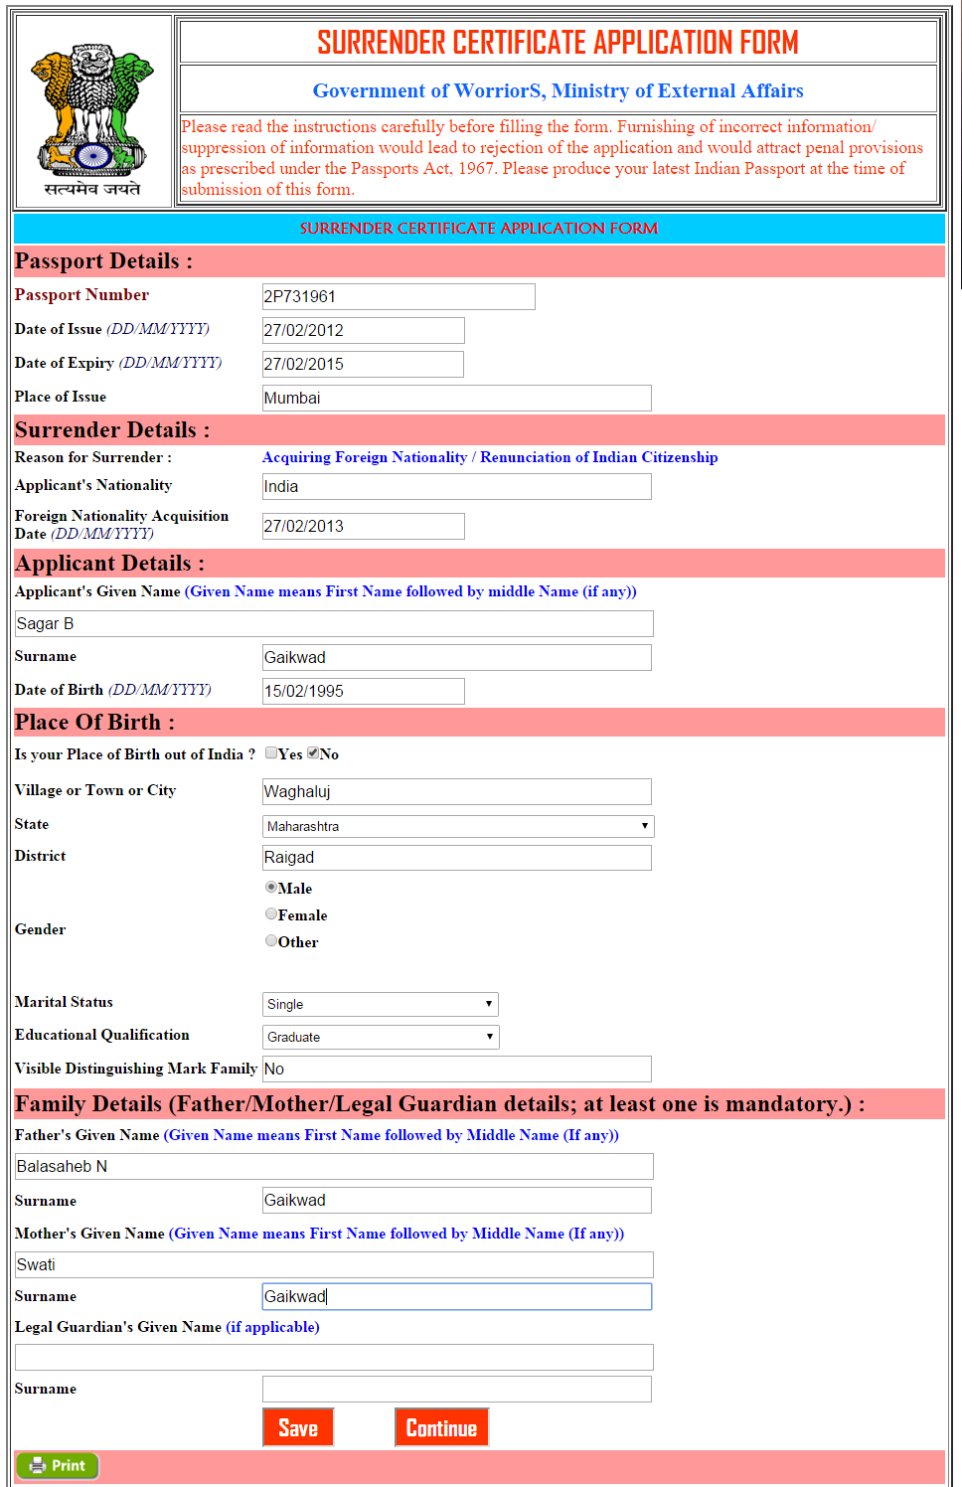

**Pseudo Code:**

|  |  |  |  |
| --- | --- | --- | --- |
| **Sr. No.** | **Name** | **Procedure** | **Description** |
| 1 | Save | Click | Used to Save the Form. |
| 2 | Continue | Click | Used to go to Next Form. |

**Code:**

using System;

using System.Collections.Generic;

using System.Linq;

using System.Web;

using System.Web.UI;

using System.Web.UI.WebControls;

using System.Data;

using System.Data.SqlClient;

using System.Configuration;

public partial class SurrenderCertificateApplicationForm1 : System.Web.UI.Page

{

SqlConnection con = new SqlConnection(ConfigurationManager.ConnectionStrings["ConnectionString"].ConnectionString);

protected void Page_Load(object sender, EventArgs e)

{

btnContinue.Visible = false;

txtApplicantNationality.Focus();

}

protected void Save_Click(object sender, EventArgs e)

{

con.Open();

string query = "Select userId from NewUserRegistration where Login_id='" + Session["Username"] + "' ";

SqlDataAdapter sa = new SqlDataAdapter(query, con);

DataTable dt = new DataTable();

sa.Fill(dt);

int userid = Convert.ToInt32(dt.Rows[0][0]);

SqlCommand cmd = new SqlCommand("INSERT INTO SurrenderCertificateApplicationForm1 (userID,Passport_Number,Date_of_Issue,Date_of_Expiry,Place_of_Issue,Applicants_Nationality,Foreign_Nationality_Acquisition_Date,Applicants_Given_Name,Applicants_Given_SurName,Date_of_Birth,Birth_out_of_India,Village_Town_City,State,District,Gender,Marital_Status,Educational_Qualification,Visible_Dist_MarkFamily,FatherGivenName,FatherGivenSurname,MotherGivenName,MotherGivenSurname,Guardian_Given_Name,Guardian_Given_Surname) VALUES('" + userid + "','" + txtPassportNumber.Text + "','" + txtDate_of_Issue.Text + "','" + txtDate_of_Expiry.Text + "','" + txtPlace_of_Issue.Text + "','" + txtApplicantNationality.Text + "','" + txtForeignNationalityAcquisitionDate.Text + "','" + txtApplicantGivenName.Text + "','" + txtApplicantGivenSurname.Text + "','" + txtDate_of_Birth.Text + "','" + cblBirth_out_of_India.Text + "','" + txtVillage_Town_City.Text + "','" + ddlState.Text + "','" + txtDistrict.Text + "','" + rdblGender.Text + "','" + ddlMaritalStatus.Text + "','" + ddlEducationalQualification.Text + "','" + txtVisibleDistMarkFamily.Text + "','" + txtFatherGivenName.Text + "','" + txttxtFatherGivenSurname.Text + "','" + txtMotherGivenName.Text + "','" + txtMotherGivenSurname.Text + "','" + txtGuardian_Given_Name.Text + "','" + txttxtGuardian_Given_Surname.Text + "')", con);

try

{

cmd.ExecuteNonQuery();

con.Close();

Response.Write("<script>alert('Data is Sucessfull Save Into DataBase')</script>");﻿

btnContinue.Visible = true;

}

catch (Exception e2)

{

Response.Write(e2.Message);

}

}

protected void btnContinue_Click(object sender, EventArgs e)

{

Response.Redirect("SurrenderCertificateApplicationForm2.aspx");

}

}

**Program Name:** SurrenderCertificate.aspx

**Program Function:** This form used for Apply Surrender Certificate

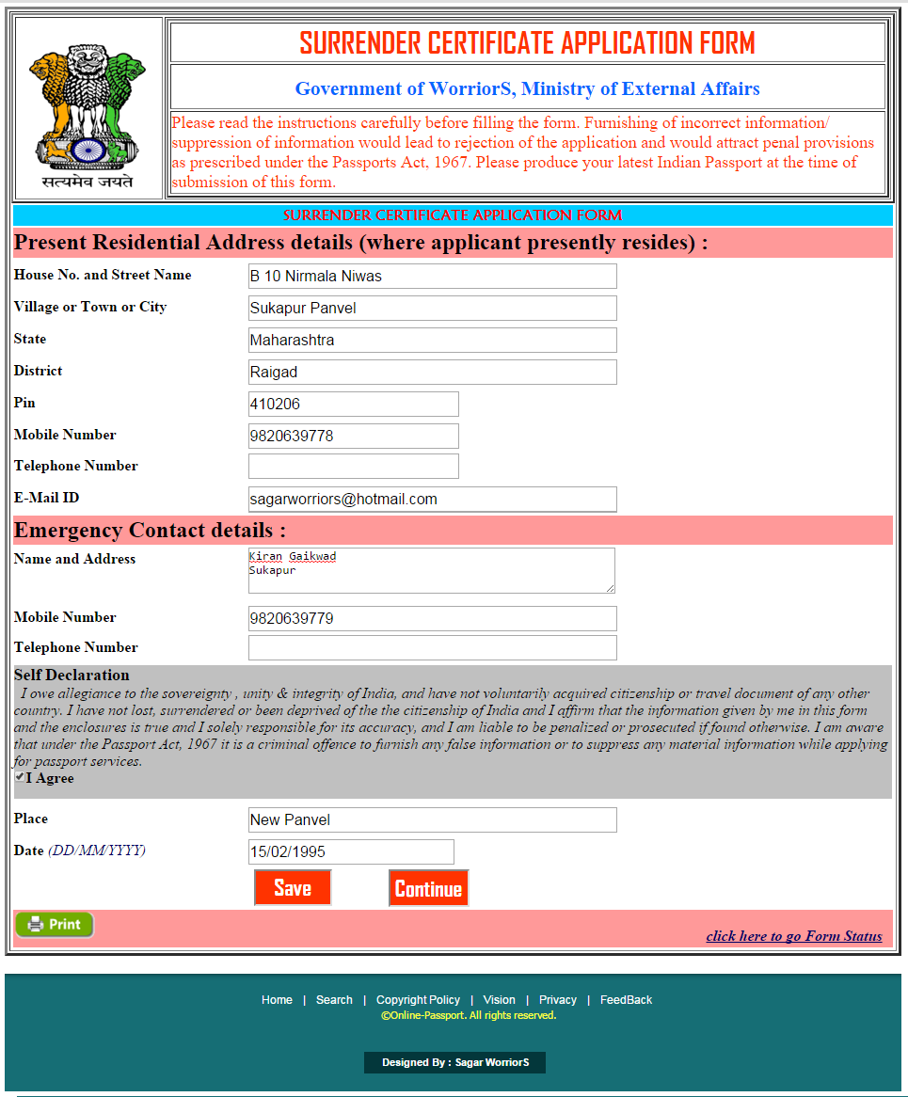

**Pseudo Code:**

|  |  |  |  |
| --- | --- | --- | --- |
| **Sr. No.** | **Name** | **Procedure** | **Description** |
| 1 | Save | Click | Used to Save the Form. |
| 2 | Continue | Click | Used to go to Next Form. |

**Code:**

using System;

using System.Collections.Generic;

using System.Linq;

using System.Web;

using System.Web.UI;

using System.Web.UI.WebControls;

using System.Data;

using System.Data.SqlClient;

using System.Configuration;

public partial class SurrenderCertificateApplicationForm2 : System.Web.UI.Page

{

SqlConnection con = new SqlConnection(ConfigurationManager.ConnectionStrings["ConnectionString"].ConnectionString);

protected void Page_Load(object sender, EventArgs e)

{

btnContinue.Enabled = false;

}

protected void btnSave_Click(object sender, EventArgs e)

{

con.Open();

string query = "Select userId from NewUserRegistration where Login_id='" + Session["Username"] + "' ";

SqlDataAdapter sa = new SqlDataAdapter(query, con);

DataTable dt = new DataTable();

sa.Fill(dt);

int userid = Convert.ToInt32(dt.Rows[0][0]);

SqlCommand cmd = new SqlCommand("INSERT INTO SurrenderCertificateApplicationForm2 (userID,HouseNo_StreetName,Village_Town_City,State,District,Pin,Mobile_No,Telephone_No,Email_ID,EmgName_Address,EmgMobile_No,EmgTelephone_No,Place,Submission_Date) VALUES('" + userid + "','" + txtHouseNoStreetName.Text + "','" + txtVillage_Town_City.Text + "','" + txtState.Text + "','" + txtDistrict.Text + "','" + txtPin.Text + "','" + txtMobileNumber.Text + "','" + txtTelephoneNumber.Text + "','" + txtEmailID.Text + "','" + txtEmgNameAddress.Text + "','" + txtEmgMobileNumber.Text + "','" + txtEmgTelephoneNumber.Text + "','" + txtPlace.Text + "','" + txtSubmission_Date.Text + "')", con);

try

{

cmd.ExecuteNonQuery();

con.Close();

Response.Write("<script>alert('Data is Sucessfull Save Into DataBase')</script>");﻿

btnContinue.Enabled = true;

}

catch (Exception e2)

{

Response.Write(e2.Message);

}

}

protected void btnContinue_Click1(object sender, EventArgs e)

{

Response.Redirect("FormStatus.aspx");

}

}

**Program Name :**IdentityCertificateForm.aspx

**Program Function:** This form used for Apply Identity Certificate

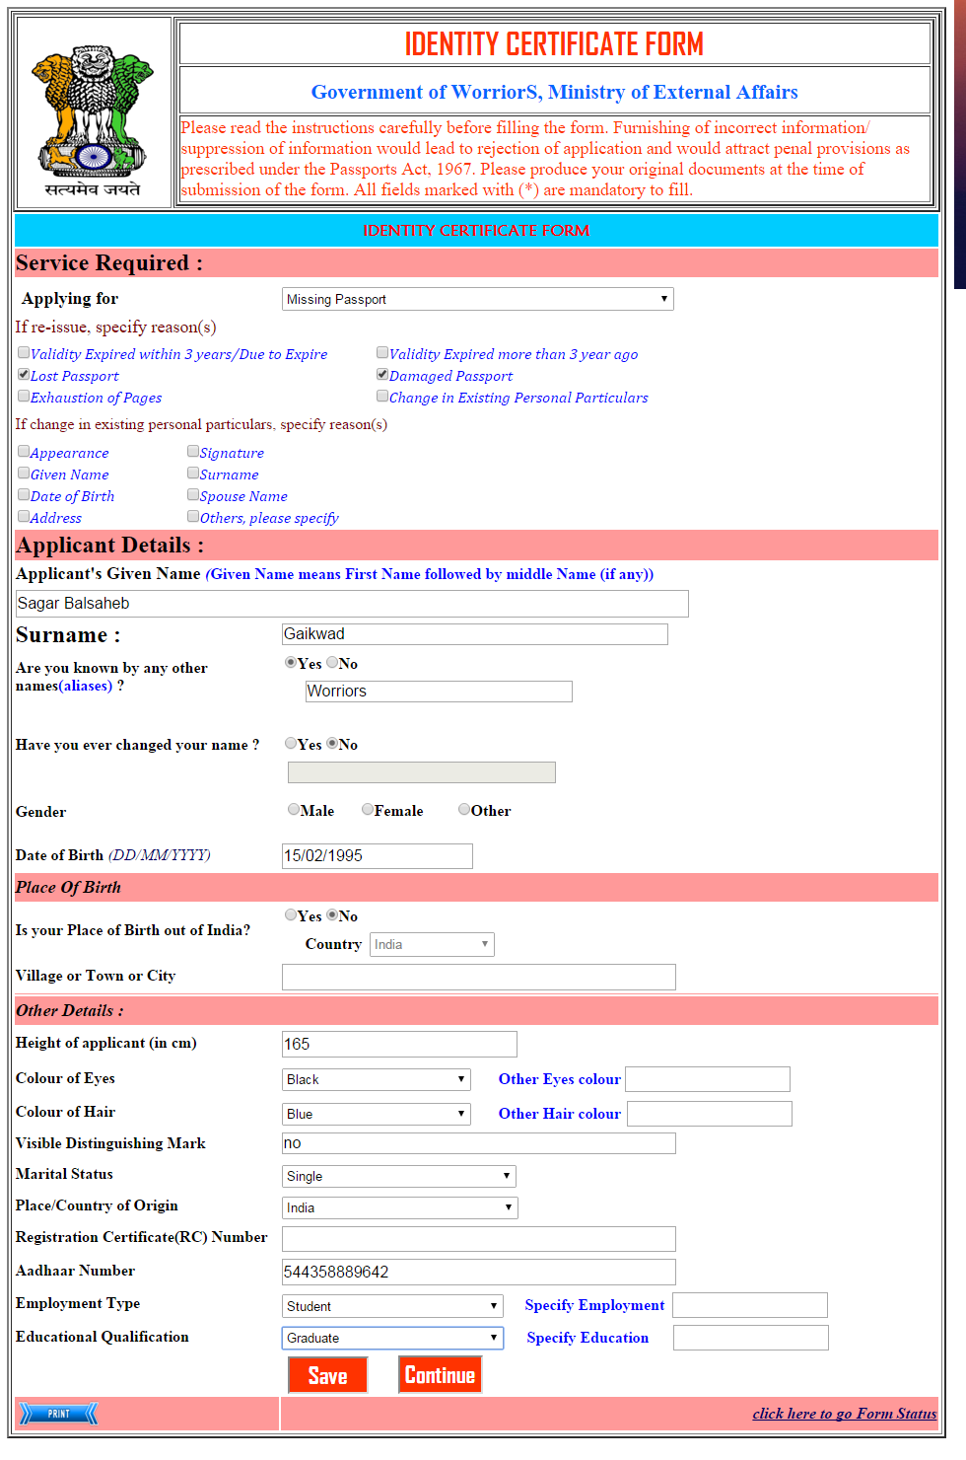

**Pseudo Code:**

|  |  |  |  |
| --- | --- | --- | --- |
| **Sr. No.** | **Name** | **Procedure** | **Description** |
| 1 | Save | Click | Used to Save the Form. |
| 2 | Continue | Click | Used to go to Next Form. |

**Code:**

using System;

using System.Collections.Generic;

using System.Linq;

using System.Web;

using System.Web.UI;

using System.Web.UI.WebControls;

using System.Data;

using System.Data.SqlClient;

using System.Configuration;

public partial class IdentityCertificateForm1 : System.Web.UI.Page

{

protected void Page_Load(object sender, EventArgs e)

{

if (!IsPostBack)

{

txtOtherNames.Focus();

btncontinue.Enabled = false;

}

}

protected void btnSave_Click(object sender, EventArgs e)

{

SqlConnection con = new SqlConnection(ConfigurationManager.ConnectionStrings["ConnectionString"].ConnectionString);

SqlCommand cmd = new SqlCommand("INSERT INTO IdentityCertificateForm1 (Applying_for,Applicantss_Given_Name,Surname,OtherNamesYes_No,OtherNamesYes,ChangedName_Yes_No,ChangedName_Yes,Gender,Date_of_Birth,BirthOutofIndia_Yes_No,Country,Village_Town_City,Height,Colour_Eyes,OtherColour_Eyes,Colour_Hair,OtherColour_Hair,Visible_Dist_Mark,Marital_Status,Place_Country_Origin,RC_Number,Aadhaar_Number,Employment_Type,OtherEmployment_Type,Educational_Qualification,OtherEducational_Qualification) VALUES('" + ddlServiceapply.Text + "','" + txtApplicantName.Text + "','" + txtSurname.Text + "','" + chlOthernames.Text + "','" + txtOtherNames.Text + "','" + chlChangedName.Text + "','" + txtChangedNames.Text + "','" + rdbGender.Text + "','" + txtDateofBirth.Text + "','" + chlBirthOutIndia.Text + "','" + ddlCountryOutIndia.Text + "',' " + txtTown.Text + " ', '" + txtHeight.Text + "','" + ddlEyeColor.Text + "', '" + txtOtherEyeColor.Text + "', '" + ddlHairColor.Text + "', '" + txtOtherHairColor.Text + "', '" + txtVisibleDistMark.Text + "', '" + ddlMaritalStatus.Text + "', '" + ddlPlace.Text + "', '" + txtRCNumber.Text + "', '" + txtAadharNumber.Text + "', '" + ddlEmploymentType.Text + "','" + txtOtherEmpType.Text + "','" + ddlEducationalQualification.Text + "','" + txtOtherEduQualification.Text + "')", con);

con.Open();

cmd.ExecuteNonQuery();

con.Close();

Response.Write("<script>alert('Data save Sucessfull...')</script>");﻿

btncontinue.Enabled = true;

}

protected void btncontinue_Click(object sender, EventArgs e)

{

Response.Redirect("IdentityCertificateForm2.aspx");

}

protected void chlOthernames_SelectedIndexChanged(object sender, EventArgs e)

{

if (chlOthernames.SelectedIndex == 0)

{

txtOtherNames.Enabled = true;

}

else

{

txtOtherNames.Enabled = false;

}

}

protected void chlChangedName_SelectedIndexChanged(object sender, EventArgs e)

{

if (chlChangedName.SelectedIndex == 0)

{

txtChangedNames.Enabled = true;

}

else

{

txtChangedNames.Enabled = false;

}

}

protected void chlBirthOutIndia_SelectedIndexChanged(object sender, EventArgs e)

{

if (chlBirthOutIndia.SelectedIndex == 0)

{

ddlCountryOutIndia.Enabled = true;

}

else

{

ddlCountryOutIndia.Enabled = false;

}

}

}

**Program Name :**IdentityCertificateForm.aspx

**Program Function:** This form used for Apply Identity Certificate

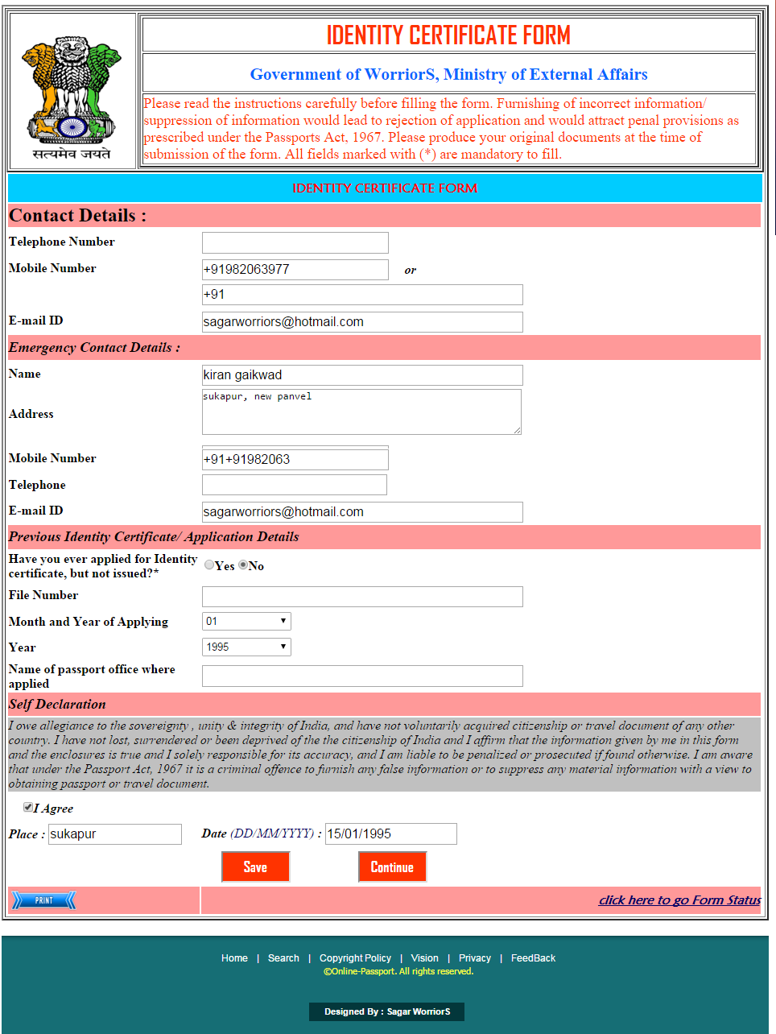

**Pseudo Code:**

|  |  |  |  |
| --- | --- | --- | --- |
| **Sr. No.** | **Name** | **Procedure** | **Description** |
| 1 | Save | Click | Used to Save the Form. |
| 2 | Continue | Click | Used to go to Next Form. |

**Code:**

using System;

using System.Collections.Generic;

using System.Linq;

using System.Web;

using System.Web.UI;

using System.Web.UI.WebControls;

using System.Data;

using System.Data.SqlClient;

using System.Configuration;

public partial class IdentityCertificateForm3 : System.Web.UI.Page

{

protected void Page_Load(object sender, EventArgs e)

{

if (!IsPostBack)

{

txtEmg_MobNo.Focus();

}

}

protected void btnSave_Click(object sender, EventArgs e)

{

SqlConnection con = new SqlConnection(ConfigurationManager.ConnectionStrings["ConnectionString"].ConnectionString);

SqlCommand cmd = new SqlCommand("INSERT INTO IdentityCertificateForm3 (Telephone_No,Mobile_No,Mobile_NoOR,EmailID,E_Name,E_Address,E_Mobile_No,E_Telephone_No,E_EmailID,Applied_for_Identity,File_Number,Month_Applying,Year_Applying,AppliedOffice,Place,Date) VALUES('" + txtTel_Number.Text + "','" + txtMob_Number.Text + "','" + txtMobNumberOR.Text + "','" + txtEmail_ID.Text + "','" + txtEmgName.Text + "','" + txtEmg_Add.Text + "','" + txtEmg_MobNo.Text + "','" + txtEmg_TelNo.Text + "','" + txtEmg_Email_ID.Text + "','" + cblApplied_for_Identity.Text + "','" + txtFile_Num.Text + "',' " + ddlMonth_Apply.Text + " ', '" + ddlYear_Apply.Text + "','" + txtPassporOfficeName_Apply.Text + "', '" + txtPlace.Text + "', '" + txtSubDate.Text + "')", con);

con.Open();

cmd.ExecuteNonQuery();

con.Close();

Response.Write("<script>alert('Data save Sucessfull...')</script>");﻿

}

protected void ImageButton1_Click(object sender, ImageClickEventArgs e)

{

Response.Redirect("FormStatus.aspx");

}

protected void chbAgree_CheckedChanged(object sender, EventArgs e)

{

if (chbAgree.Checked == false)

{

Response.Write("<script>alert('Check I Agree Checkbox ...')</script>");﻿

chbAgree.Focus();

}

}

protected void cblApplied_for_Identity_SelectedIndexChanged(object sender, EventArgs e)

{

if (cblApplied_for_Identity.SelectedIndex == 0)

{

if (txtFile_Num.Text == "")

{

Response.Write("<script>alert('Enter File Number ')</script>");﻿

txtFile_Num.Focus();

}

if (txtPassporOfficeName_Apply.Text == "")

{

Response.Write("<script>alert('Enter Passport office where you applied ')</script>");﻿

txtFile_Num.Focus();

}

}

}

protected void btnContinue_Click(object sender, EventArgs e)

{

Response.Redirect("FormStatus.aspx");

}

}

**Program Name :**Payments.aspx

**Program Function:** This form used for Payments.



**Pseudo Code:**

|  |  |  |  |
| --- | --- | --- | --- |
| **Sr. No.** | **Name** | **Procedure** | **Description** |
| 1 | Save | Click | Used to Save the Form. |
| 2 | Continue | Click | Used to go to Next Form. |

**Code:**

using System;

using System.Collections.Generic;

using System.Linq;

using System.Web;

using System.Web.UI;

using System.Web.UI.WebControls;

using System.Data;

using System.Data.SqlClient;

using System.Configuration;

public partial class Payments : System.Web.UI.Page

{

SqlConnection con = new SqlConnection(ConfigurationManager.ConnectionStrings["ConnectionString"].ConnectionString);

protected void Page_Load(object sender, EventArgs e)

{

if (Session["UserName"] != null)

lblUser.Text = "Welcome to...! : " + Session["UserName"];

if (Session["Passport No"] != null)

lblPassportNo.Text = "Your Passport No: " + Session["Passport No"];

txtCardNo.Focus();

}

protected void btnSave_Click(object sender, EventArgs e)

{

string query = "Select userId from NewUserRegistration where Login_id='" + Session["Username"] + "' ";

SqlDataAdapter sa = new SqlDataAdapter(query, con);

DataTable dt = new DataTable();

sa.Fill(dt);

int userid = Convert.ToInt32(dt.Rows[0][0]);

SqlCommand cmd = new SqlCommand("INSERT INTO Payments (userID,TypeOfPayment,txtBankName,ddlCardType,txtCardNo,txtCCVNumber,txtMonthYear) VALUES('" + userid + "','" + rblTypePayment.Text + "','" + ddlBank.Text + "','" + ddlCardType.Text + "','" + txtCardNo.Text + "','" + txtCCVNumber.Text + "','" + txtMonthYear.Text + "')", con);

con.Open();

cmd.ExecuteNonQuery();

con.Close();

Response.Write("<script>alert('Payment Details is save Sucessfull...')</script>");﻿

lblMessage.Text = "Payment has Successfully...";

}

protected void rblTypePayment_SelectedIndexChanged(object sender, EventArgs e)

{

if (rblTypePayment.SelectedIndex == 0)

{

Response.Redirect("CashPayment.aspx");

}

else

{

rblTypePayment.AutoPostBack = false;

}

}

protected void ImageButton1_Click(object sender, ImageClickEventArgs e)

{

Response.Redirect("FormStatus.aspx");

}

}

**Program Name :**AppointmnetStatus.aspx

**Program Function:** This form used for information about Appointment.



**Code :**

using System;

using System.Collections.Generic;

using System.Linq;

using System.Web;

using System.Web.UI;

using System.Web.UI.WebControls;

public partial class AppointmentStatus : System.Web.UI.Page

{

protected void Page_Load(object sender, EventArgs e)

{

}

protected void btnCheck_Click(object sender, EventArgs e)

{

if (rblTypeService.SelectedIndex == 0)

{

if (ddlFrom.SelectedIndex == 0)

{

DateTime dt = DateTime.Now;

dt = dt.AddDays(15);

lblMessage.Text = "Your Appointments date are :" + dt.ToString();

}

}

if (rblTypeService.SelectedIndex == 1)

{

if (ddlFrom.SelectedIndex == 1)

{

DateTime dt = DateTime.Now;

dt = dt.AddDays(6);

lblMessage.Text = "Your Appointments date are :"+dt.ToString();

}

}

if (rblTypeService.SelectedIndex == 1)

{

if (ddlFrom.SelectedIndex == 0)

{

DateTime dt = DateTime.Now;

dt = dt.AddDays(13);

lblMessage.Text = "Your Appointments date are :" + dt.ToString();

}

}

if (rblTypeService.SelectedIndex == 0)

{

if (ddlFrom.SelectedIndex == 1)

{

DateTime dt = DateTime.Now;

dt = dt.AddDays(4);

lblMessage.Text = "Your Appointments date are :" + dt.ToString();

}

}

}

protected void ImageButton1_Click(object sender, ImageClickEventArgs e)

{

Response.Redirect("FormStatus.aspx");

}

}

**Program Name :**OnlineFormSubmission.aspx

**Program Function:** This form used for information of Aboutonline form Submission.

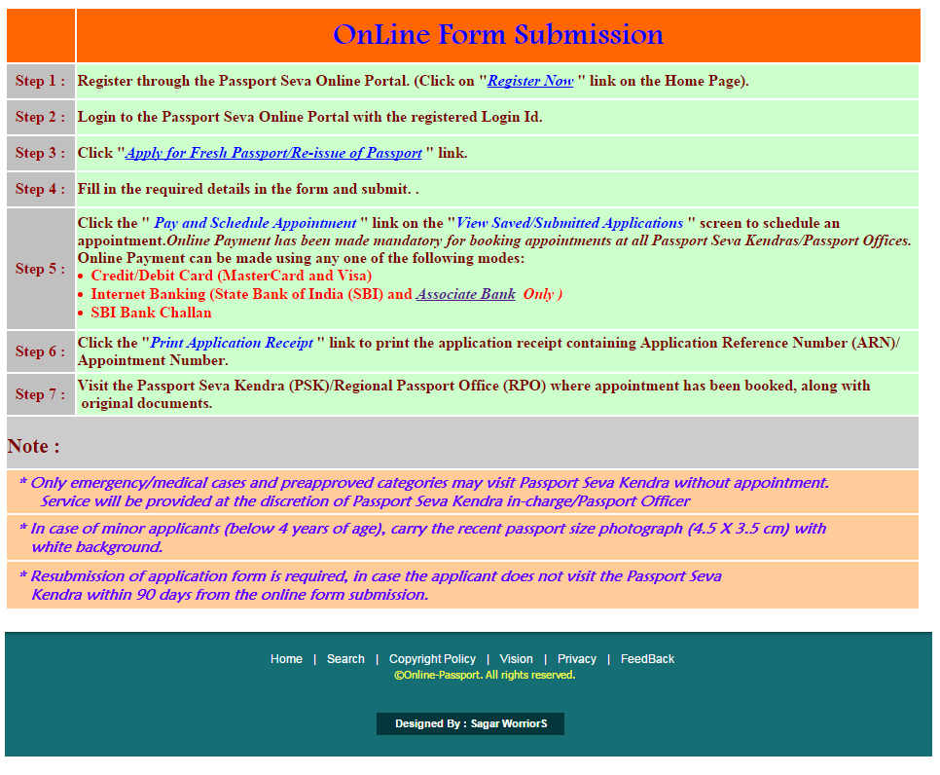

**Program Name :**FeesCalculaion.aspx

**Program Function:** This form used for Calculation of fees



**Code :**

using System;

using System.Collections.Generic;

using System.Linq;

using System.Web;

using System.Web.UI;

using System.Web.UI.WebControls;

public partial class FeesCalculation : System.Web.UI.Page

{

protected void Page_Load(object sender, EventArgs e)

{

btnCheck.Focus();

}

protected void btnCheck_Click(object sender, EventArgs e)

{

// checking for Jammu and Kashmir

if (rblTypeApplicant.SelectedIndex == 0)

{

if(ddlFrom.SelectedIndex == 0)

{

lblMessage.Text="Your Normal Total Fees Will be Rs 3000 & Verification Charge ";

}

}

if (rblTypeApplicant.SelectedIndex == 1)

{

if(ddlFrom.SelectedIndex == 0)

{

lblMessage.Text = "Your Normal Total Fees Will be Rs 6000 & Verification Charge";

}

}

if (rblTypeApplicant.SelectedIndex == 2)

{

if(ddlFrom.SelectedIndex == 0)

{

lblMessage.Text = "Your Normal Total Fees Will be Rs 4500 & Verification Charge";

}

}

// checking for Other India Region

if (rblTypeApplicant.SelectedIndex == 0)

{

if (ddlFrom.SelectedIndex == 1)

{

lblMessage.Text = "Your Normal Total Fees Will be Rs 2000 & Verification Charge";

}

}

if (rblTypeApplicant.SelectedIndex == 1)

{

if (ddlFrom.SelectedIndex == 1)

{

lblMessage.Text = "Your Normal Total Fees Will be Rs 5000 & Verification Charge";

}

}

if (rblTypeApplicant.SelectedIndex == 2)

{

if (ddlFrom.SelectedIndex == 1)

{

lblMessage.Text = "Your Normal Total Fees Will be Rs 3500 & Verification Charge";

}

}

}

protected void ImageButton1_Click(object sender, ImageClickEventArgs e)

{

Response.Redirect("HomePage.aspx");

}

}

**Program Name :**FeedBack.aspx

**Program Function:** This form used for FeedBack



**Code :**

using System;

using System.Collections.Generic;

using System.Linq;

using System.Web;

using System.Web.UI;

using System.Web.UI.WebControls;

using System.Data.SqlClient;

using System.Configuration;

public partial class FeedBack : System.Web.UI.Page

{

protected void Page_Load(object sender, EventArgs e)

{

txtFileNo.Focus();

}

protected void ImgSubmit_Click(object sender, ImageClickEventArgs e)

{

SqlConnection con = new SqlConnection(ConfigurationManager.ConnectionStrings["ConnectionString"].ConnectionString);

SqlCommand cmd = new SqlCommand("INSERT INTO Feedback (Name, Mob, EmaidID, file_No, feedback) VALUES('" + txtName.Text + "','" + txtMobileNo.Text + "','" + txtEmailID.Text + "','" + txtFileNo.Text + "','" + txtFeedBack.Text + "')", con);

con.Open();

cmd.ExecuteNonQuery();

con.Close();

Response.Write("<script>alert('Thank you for Given FeedBack...')</script>");﻿

}

protected void ImgCancel_Click(object sender, ImageClickEventArgs e)

{

txtName.Text = "";

txtEmailID.Text = "";

txtFeedBack.Text = "";

txtFileNo.Text = "";

txtMobileNo.Text = "";

}

}

**Program Name :**ContactDetails.aspx

**Program Function:** This form used for Information Contact Details



**Program Name :**Aboutus.aspx

**Program Function:** This form used for Information Aboutus

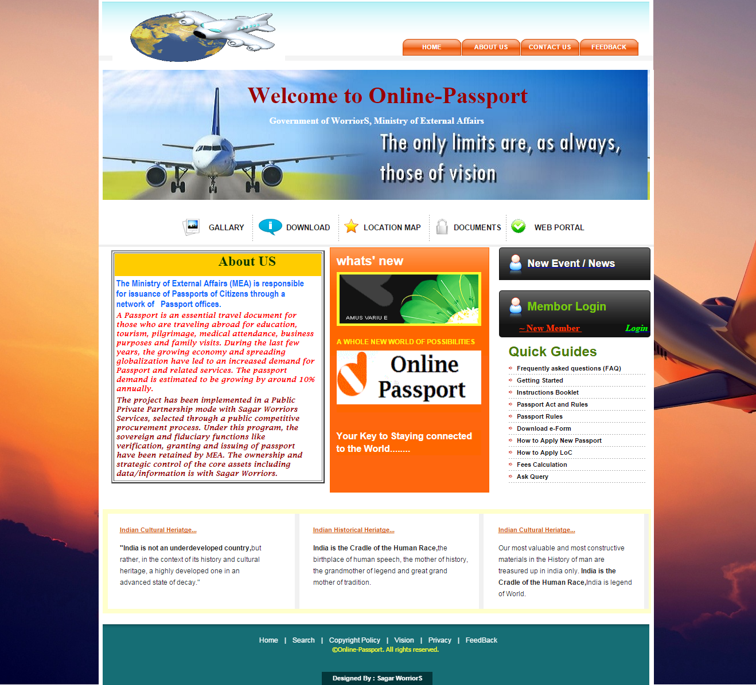

**Program Name :**WebPortal.aspx

**Program Function:** This form used for Information About WebPortal



**Program Name :**LocationMap.aspx

**Program Function:** This form used for Information About Location Map



**Program Name :**ChangePassword.aspx

**Program Function:** This form used for Change password



**Code :**

using System;

using System.Collections.Generic;

using System.Linq;

using System.Web;

using System.Web.UI;

using System.Web.UI.WebControls;

using System.Data;

using System.Data.SqlClient;

using System.Configuration;

public partial class ChangePassword : System.Web.UI.Page

{

SqlConnection conn = new SqlConnection(ConfigurationManager.ConnectionStrings["ConnectionString"].ConnectionString);

protected void Page_Load(object sender, EventArgs e)

{

txtConPass.Focus();

lblusername.Text = Session["UserName"].ToString();

SqlCommand com1;

String str1;

conn.Open();

str1 = "select * from NewUserRegistration where Login_ID='" + lblusername.Text + "'";

com1 = new SqlCommand(str1, conn);

SqlDataReader reader1 = com1.ExecuteReader();

if (reader1.Read())

{

lblsque.Text = reader1["Hint_Question"].ToString();

reader1.Close();

conn.Close();

}

}

protected void btnSubmit_Click(object sender, EventArgs e)

{

SqlDataAdapter sda = new SqlDataAdapter("select Password from NewUserRegistration where Login_ID='" + lblusername.Text + "' and Hint_Answer='"+txtans.Text+"' ", conn);

DataTable dt = new DataTable();

sda.Fill(dt);

if (dt.Rows.Count.ToString() == "1")

{

if (txtNewPassword.Text == txtConPass.Text)

{

conn.Open();

SqlCommand cmd = new SqlCommand("Update NewUserRegistration set Password='" + txtConPass.Text + "' where Password='" +txtOldPassword.Text+ "'", conn);

cmd.ExecuteNonQuery();

conn.Close();

Response.Write("<script>alert('Password change successfully go to login again with new password')</script>");﻿

Session.RemoveAll();

changepass.Text = "your Password change successfully...";

}

else

{

changepass.Text = "New password and confirm password should be same";

changepass.ForeColor = System.Drawing.Color.Red;

txtOldPassword.Text = "";

txtNewPassword.Text = "";

txtConPass.Text = "";

}

}

else

{

changepass.Text = "Please Check Your Old Password";

changepass.ForeColor = System.Drawing.Color.Red;

txtOldPassword.Text = "";

txtNewPassword.Text = "";

txtConPass.Text = "";

}

}

}

**Program Name :**AdminHome.aspx

**Program Function:** This form used for Information About Admin Home Page



**Report Layouts with Code**

**Report Name: -**UserRegistered.rpt

**Report function: -** This form displays report of New User Registered.

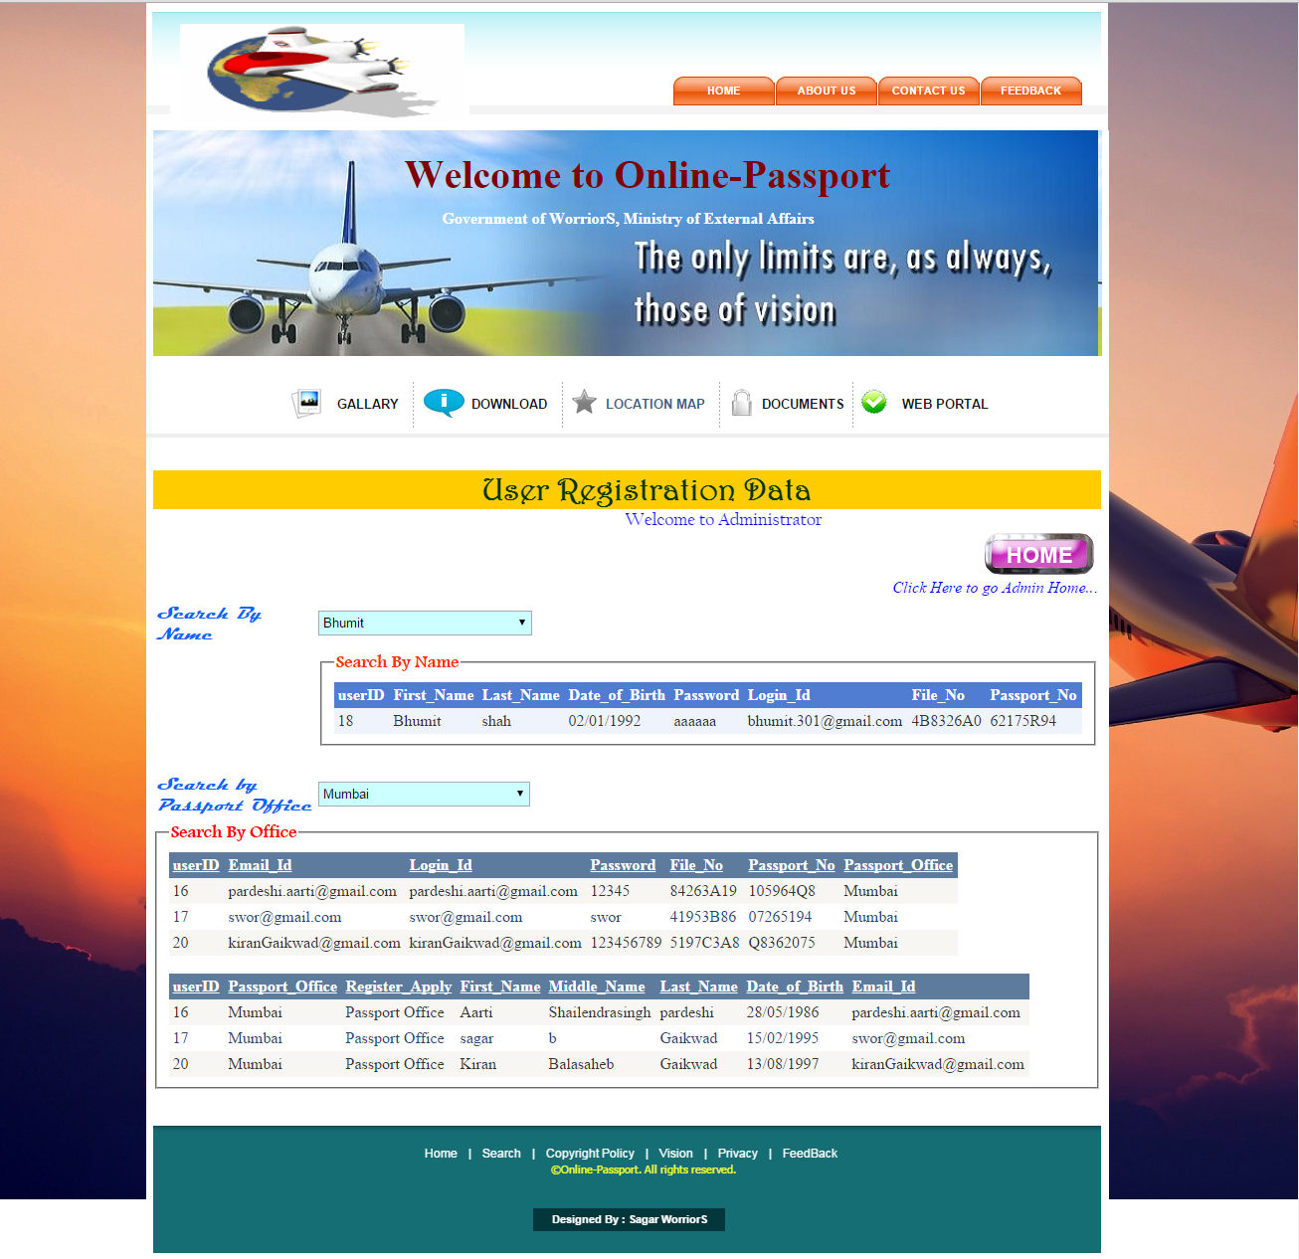

**Report Name: -**Query.rpt

**Report function: -** This form displays report of Applicant or Visitor Query

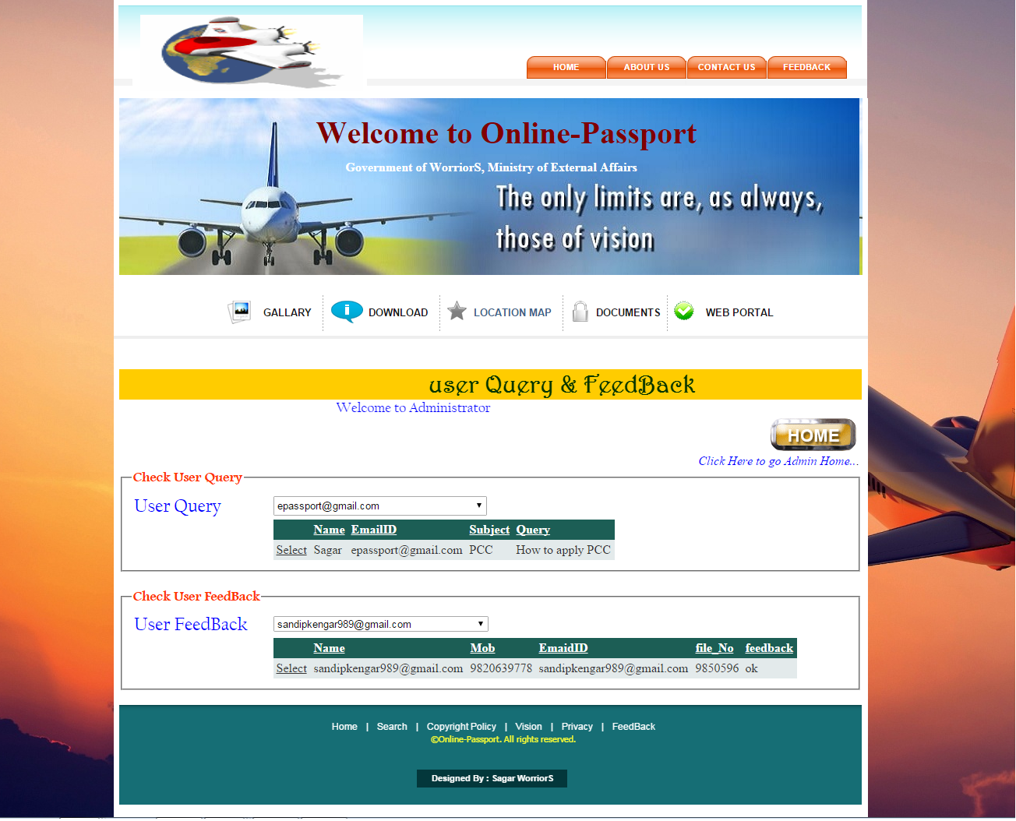.

**Report Name: -**AdminFeedBack.rpt

**Report function: -** This form displays report of Applicant or Visitor FeedBack



**Chapter 5**

**System Implementation &Uploading**

**System Implementation**

The System developed will be implemented for Online Passport

* The Website required for the Web Host on World Wide .
* All required records are added in the database.
* For regular transaction the system will be used very well.

**SYSTEM CONTROL & STANDARD**

1. **Access Control**

System gives access by valid password.

1. **Input Control**

System validates every textbox. It allows textual values for fields like Applicant name. It also validates some numeric data only for fields like phone no.

1. **System Generate control**

In Appoitnment details it automatically Gives Appointment for Applicant similarly in Payments details it automatically deducts the amount from the actual amount.

**Chapter 6**

**Future Enhancement**

**Future Enhancement**

Being a computer system, the system has good scope to be improved further. It not only carried out work faster but also efficiently. A lot of manual work likes searching; personal alias is reduced to a large extent. As this is computerized system the management is completely depends on computer for accessing details about events. Here in case there is power failure or some hardware problem which cannot be fixed easily, the manager cannot continue this work. He gets struck in the middle of the day this dealing need to be postponed.

Also the software needs to be maintained from time to time, i.e. if it requires to updated or modified etc. then management need to take care of it.

Future enhancements are as listed below.

Administrator can be given more rights so that he will be able to change Passport or Applicant details.

The Online Payments will be requiringmore secure encryption to provide more secure transaction.

Applicant should be given with rewards point for frequent Access.

Weekly or Monthly or Yearly report will be generating.

**Chapter 7**

**CONCLUSION**

**Conclusion**

* We have designed the project to provide the user with easy navigation, retrieval of data and necessary feedback as much as possible.
* This project provides good Website to design must be accompanied with user-friendly Online Passport.
* It is convenient for the Applicant to view the contents of theirdetails and to be able to remove or addto their details.
* There are also chances to that Analysis details can occur which can cause huge data problem.
* The Website describedin this project provides a number of features that are designed to make the Applicant more comfortable.
* More Comfortable for all users who can handle internet.

**Chapter 8**

**References & Bibliography**

**References & Bibliography**

**Books & URL**

|  |  |  |
| --- | --- | --- |
| **Sr. No.** | **type** | **Description** |
| 1. | Book name :  Author : | Beginning ASP.NET 3.5 in VB 2008  Matthew MacDonald |
| 2. | Book name :  Author : | Professional SQL Server 2008 Integration Service  Brain knight,AllanMitchell,DarrenGreen,Mike Murphy |
| 3 | Book name :  Author : | ASP.NET in Simple Steps  Kogent Learning Solution Inc. |
| 4 | Book name :  Author : | C# in Simple Steps  Kogent Learning Solution Inc |
| 5 | Website : | <http://www.w3schools.com/aspnet/webpages_intro.asp> |
| 6 | Website : | <http://www.google.co.in> |
| 7 | Website : | http://www.c-sharpcorner.com |